

**Problem Card 1 - Homework**

There are 26 students in a class.

They get 7 pieces of homework per week. There are 38 weeks in each school year.

How many pieces do they get in a school year?



**Problem Card 2 – Book**

Toby reads 9 pages of his book each night. It takes him 5 weeks to finish his book.

How many pages long is the book?

**Problem Card 3 - Baker**

A baker bakes trays of bread buns. Each tray contains 8 buns.

Each bun sells for 35 pence.

On Monday the baker bakes 12 trays and sells all the buns. How much money does get form selling the buns?

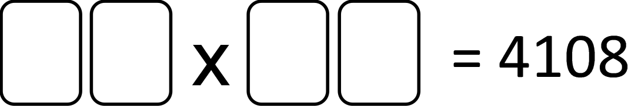

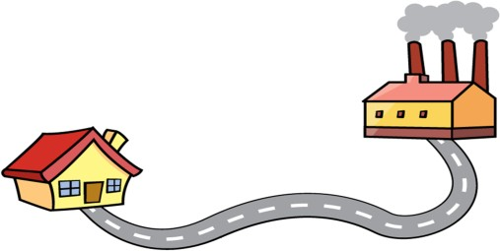

**Problem Card 4 – Work and back**

Hassan travels from his house to work and back again Monday to Friday.

The distance from his house to work is 18 miles. Fuel costs him 31 pence for every mile he drives. He fills his car with £12.50 of fuel on Monday.

Will this be enough to last him for the week?

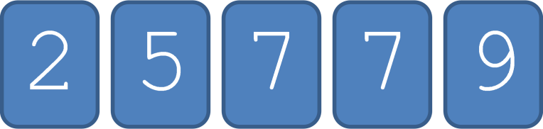

**Problem Card 5 – 4 cards**

Here are five number cards.

Choose four of the cards to make the calculation correct.