Typing Skills

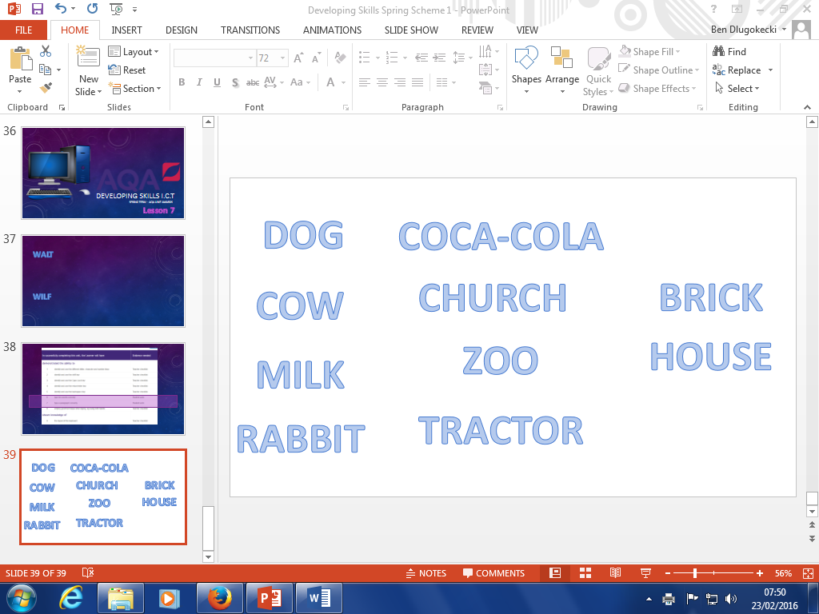

|  |  |
| --- | --- |
| http://mardaloopdoggiedaycare.com/wp-content/uploads/2014/12/cute-dog2.jpg |  |
| http://vignette4.wikia.nocookie.net/creepypasta/images/f/fc/700cow.jpg/revision/latest?cb=20110412003057 |  |
| http://i.ndtvimg.com/i/2014-11/milk_625x300_41416559876.jpg |  |

|  |  |
| --- | --- |
| http://www.bbbvet.org.uk/wp-content/uploads/2015/05/rabbit.jpg |  |
| http://www.coke.co.za/resources/images/product_selection/product_coke_bottle.png |  |
| http://www.tournorfolk.co.uk/coltishall/churchT.jpg |  |
| http://kamapublishing.co.uk/images/all%20the%20zoo.jpg |  |
| https://www.deere.com/common/media/images/product/tractors/row_crop_tractors/small_frame_series/7330/7330_tractor_459893_model_642x462.png |  |

|  |  |
| --- | --- |
| http://www.mjtimber.co.uk/store/images/engineering-brick.jpg |  |
| https://upload.wikimedia.org/wikipedia/commons/f/f8/Ellen_H._Swallow_Richards_House_Boston_MA_01.jpg |  |

**Extension** – Make your own! Find a picture and type the word!

|  |  |
| --- | --- |
|  |  |
|  |  |