What is Electricity?
LO Describe what electricity is, what is meant by current potential difference and resistance, and calculate these.
Go through the PowerPoint “Science lesson what is electricity”. Do the activities then use what you have learnt to answer these questions. When you have finished there are more activities on the last slide that you can choose from.
1) What are the negatively charged particles responsible for electrostatic force called?

2) Why do we see lightning before we hear thunder?

3) Finish this sentence. For Electrical charge to flow there needs to be a complete
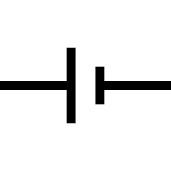
4) Label these electrical symbols with what they represent.
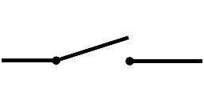

5) a. What do we use to measure current?
b. What are the units?

6) What does DC stand for and what does it mean?

7) What does AC stand for and what does it mean?

8) a. What is another name for potential difference?
b. What do we use to measure potential difference?
c. What are the units?

9) a. What is resistance?
b. What units is it measured in?

10) Potential difference = current x resistance.
If the current is 3A and the resistance is 3Ω, what is the potential difference?

11) Current is 5A, resistance is 2Ω, what is the potential difference?

12) If the potential difference is 8V and the current is 4A, what is the resistance?

13) If the potential difference is 12V and the current is 3A, what is the resistance?

14) If the potential difference is 15V and the resistance is 5Ω, what is the current?

15) If the potential difference is 6V and the resistance is 3Ω, what is the current?

