**W/C 6 April 2020**

**I can recognise and name 2D shapes**

**I can describe the properties of 2D shapes**

* Go on a Shape hunt, how many 2D shapes can you spot and name in your home?
* MyMaths <https://login.mymaths.co.uk/>

Logon: Osborne Password: square

* Please find

,  and  Activities below



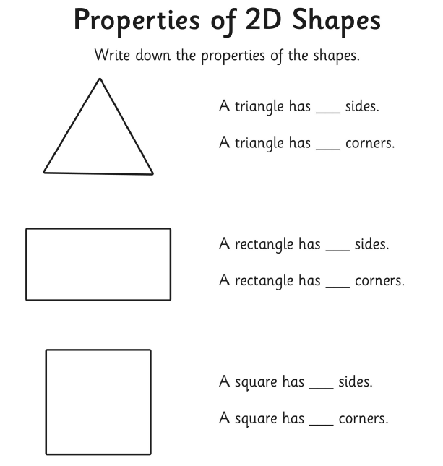

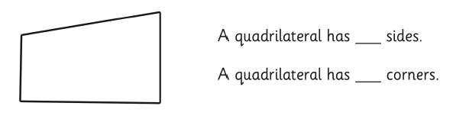

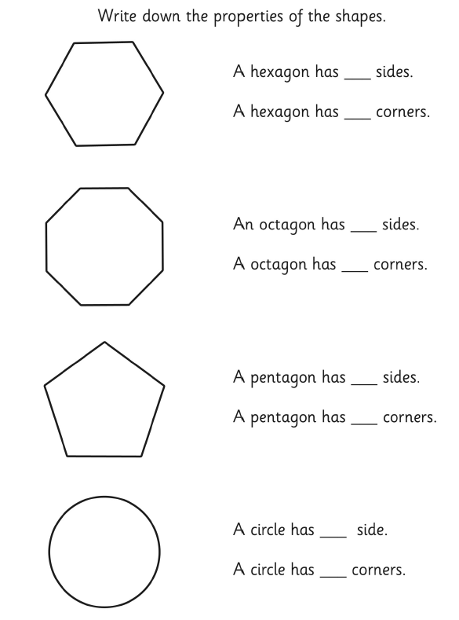

W/C 6 April 2020



**I can recognise and name 2D shapes**

**I can describe the properties of 2D shapes**

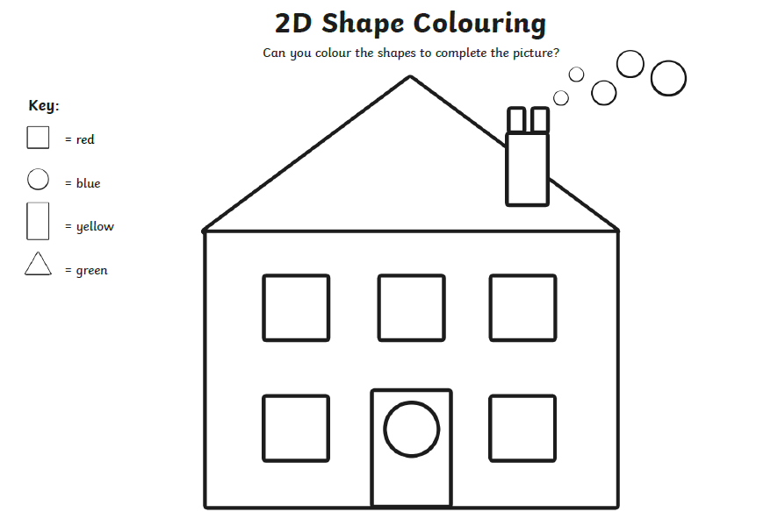

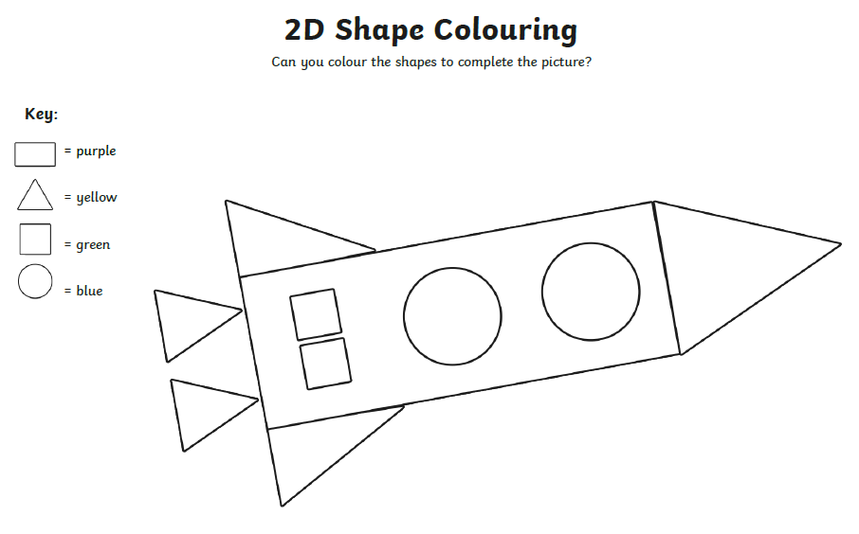

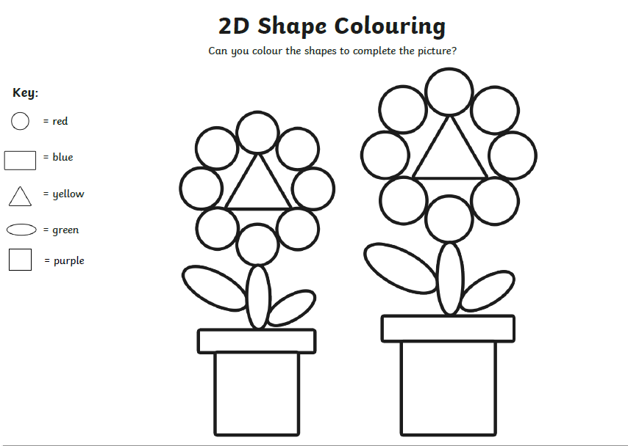



W/C 6 April 2020

**I can recognise and name 2D shapes**

**I can describe the properties of 2D shapes**

