W/C 6 March 2020
Session E  Car on ramp: surface investigation | Objectives: Understand what makes a test fair and how to measure accurately.  Sc4 2c Recognise that when things speed up, slow down or change direction there is a cause.  Breadth of study: 2a Use simple scientific language to communicate ideas and describe phenomena.  1d Use first-hand and secondary data to carry out a range of scientific investigations, including complete investigations.
Scientific enquiry | Sc1 1 Learn that it is important to collect evidence by making observations when trying to answer a question.  2d Recognise when a test or comparison is unfair.  2i Compare what happened with what they expected would happen and try and explain it, drawing on their knowledge and understanding.
Resources needed | Ramp, blocks (books?), 1 car (or something that will roll), something to measure with (this could be a ruler, a tape measure or a line of objects that are all the same eg pasta ie: the car rolled 10 pasta pieces)
Science
Today we are going to be scientists.
Investigation 1
We are going to investigate ramps and toy cars.
Don’t worry if you don’t have a toy car, you could use anything that will roll (eg a tin of beans, a rolling pin or a can of pop)
We are going to see if the higher the ramp, the further the car will travel. What do you think? Can you make a prediction?
WHY do you think this?

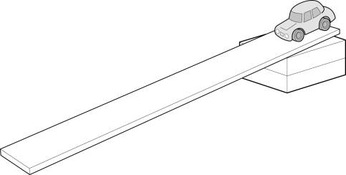
Fair test
Can we remember what a fair test is?
We can only change one variable at a time.
This is because we will not know which variable has the affect we are investigating!
So what will we keep the same? (constants)
The car, the ramp, how we measure the distance
What will we change? (variable)
The height of the ramp, use books to make the ramp higher.
Can you investigate to find out whether the car travels further when the ramp is high or low and record your results in a table?
See main activity but use the table to record results.
Height of ramp | Distance rolled measured in …
1 book
2 books
3 books
4 books
5 books
What are your findings? (conclusion) Was your prediction correct?
Next you could investigate a different variable to find out how the surface of the ramp affects the distance the car travels.
You could try using a variety of surfaces e.g. carpet, bubble wrap, wood, fabric, paper, corrugated card.
Don’t forget that now you have a new vaiable (the ramp surface) you will need to keep everything else the same (including the height of the ramp!)

