Work out the following maths calculations. Then write the corresponding letter of the alphabet from the table to reveal a secret message.
Crack the code

A | B | C | D | E | F | G | H | I | J | K | L | M
21 | 12 | 14 | 20 | 4 | 18 | 5 | 16 | 27 | 8 | 28 | 40 | 15
N | O | P | Q | R | S | T | U | V | W | X | Y | Z
3 | 7 | 0 | 9 | 24 | 22 | 13 | 6 | 19 | 23 | 17 | 72 | 1

4 x10 | 7 - 3 | 6 + 7

12 - 6 | 11+11

12 - 8 | 10+11 | 20-7

7+7 | 10+6 | 10-3 | 8+6 | 3+4 | 40 +0 | 25-4 | 5+8 | ²⁰⁻¹⁶
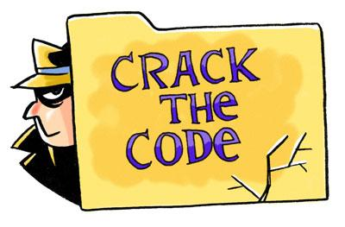

Secret Message:________________________________________________
_________________________________________________________
_________________________________________________________

