Work out the following maths calculations. Then write the corresponding letter of the alphabet from the table to reveal a secret message.
Crack the code

A | B | C | D | E | F | G | H | I | J | K | L | M
1 | 2 | 3 | 4 | 5 | 6 | 7 | 8 | 9 | 10 | 11 | 12 | 13
N | O | P | Q | R | S | T | U | V | W | X | Y | Z
14 | 15 | 16 | 17 | 18 | 19 | 20 | 21 | 22 | 23 | 24 | 25 | 26

4+4 | 5-4 | 10+6 | ⁸⁺⁸ | 20+5

10-5 | 10-9 | 10+9 | 10+10 | 0+5 | 11+7

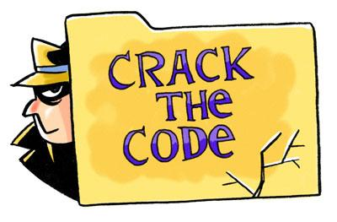

Secret Message:________________________________________________
_______________________________________________________

