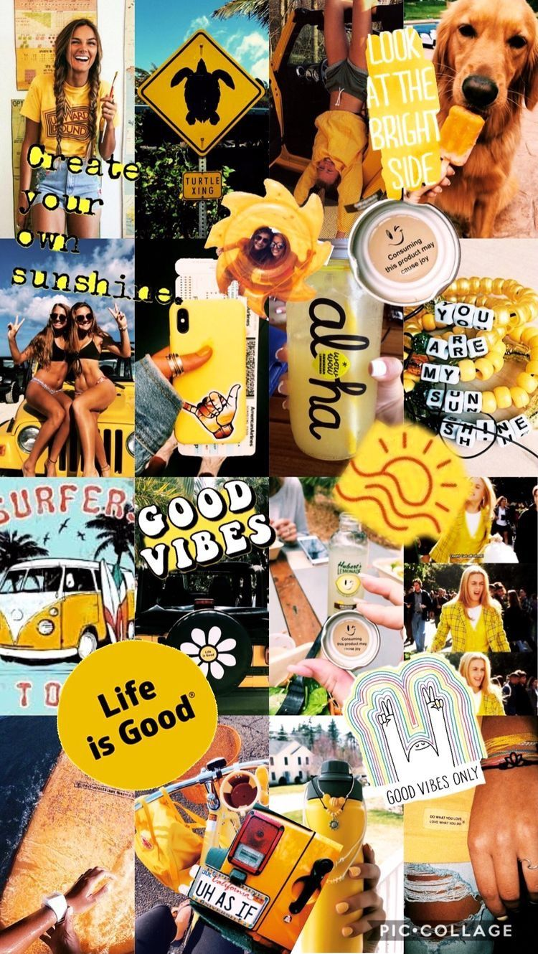
Create a photograph collage using the following requirements:
Take a photo of...
1. Something delicious
2. Something you love
3. Can you guess what it is (an everyday object photographed from an unusual angle)
4. Shot with your eyes closed
5. Fill the frame with colour
6. Something you made
7. Something that's moving
8. Something older than you
9. Bird's eye view/snail's eye view
10. Something that's alive
11. A shadow
12. 3 of a kind
13. Natural black and white
14. Something you can drink
15. Spring!
Email me any collages that you make.

