Draw these digital times as they would appear on an analogue clock.

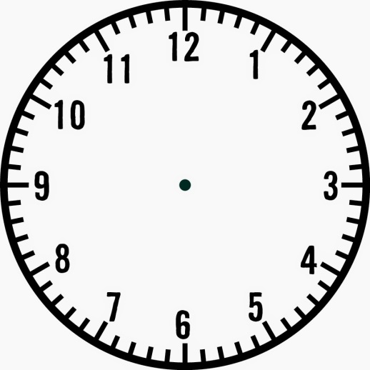
02:30 | 10:20
16:10 | 03:15
08:50 | 18:05

