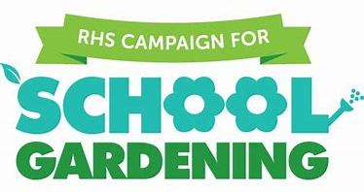
https://youtu.be/KzrEiHje8f8
Ideas for activities can be found at the RHS website

Osborne School is part of the RHS campaign for school gardening and this week is National Gardening Week. As well as completing the work and activities set by your teachers – you could try and get out and do some jobs or simply enjoy your garden. If you don’t have a garden there are lots of activities, you can do inside too.
Please, please send us photos of you working or relaxing your gardens or completing some gardening related activities. It is so lovely to see what you are all up to.
https://youtu.be/KzrEiHje8f8

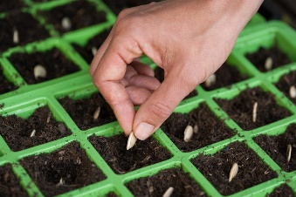
Sow some seeds
Find instructions online of how to sow any seeds you have or can buy.
https://www.rhs.org.uk/advice/grow-your-own
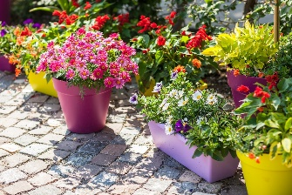
Plant a container
https://www.youtube.com/watch?v=miEYMWZrHgg

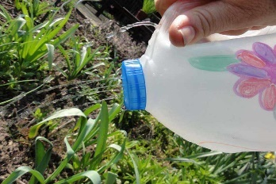
Help to Water the garden
Use a watering can or even a hose – or you could make your own
watering device
https://schoolgardening.rhs.org.uk/Resources/Activity/Make-a-watering-device
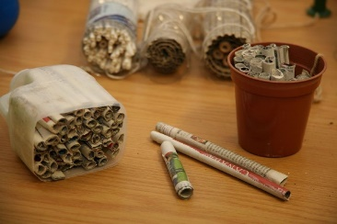
Make a simple bug or ladybird home
Make a home for bugs, bees or ladybirds

https://schoolgardening.rhs.org.uk/Resources/Activity/Make-a-simple-bug-or-ladybird-home
https://www.rspb.org.uk/get-involved/activities/give-nature-a-home-in-your-garden/garden-activities/build-a-bug-hotel/
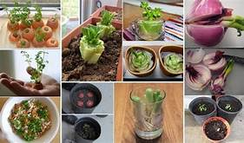
Re grow you fruit and veg
Watch things grow!
https://www.ruralsprout.com/regrow-vegetables/

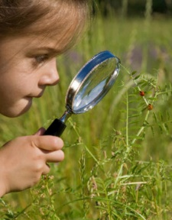
Go on a bug hunt
What is living in your garden?
https://www.woodlandtrust.org.uk/blog/2019/04/minibeast-hunt/

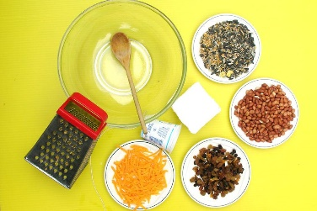
Make bird cake
Help attract birds to your garden.
https://www.rhs.org.uk/education-learning/gardening-children-schools/family-activities/Activities/activities/bird-cake
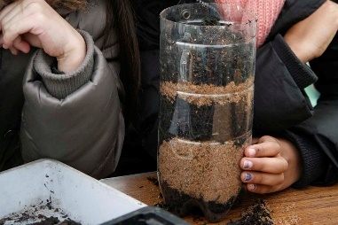
Make a wormery
Watch some worms.
https://schoolgardening.rhs.org.uk/Resources/Activity/Mini-wormery

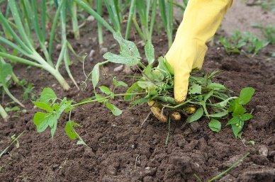
Weed a patch of Garden
https://www.youtube.com/watch?v=6d1kbpaBJlk

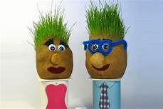
Make a grass head
You could make a grass head to look like your teacher.

http://www.gardenplotters.org.uk/uploads/files/Funky%20Grass%20Heads%20instructions.pdf

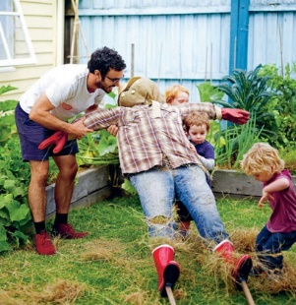
Make a scarecrow
Don’t let those birds eat your crops.
https://www.rhs.org.uk/education-learning/gardening-children-schools/family-activities/Activities/activities/make-a-scarecrow

Lots of other activities can be found …
https://www.rhs.org.uk/education-learning/gardening-children-schools/family-activities/Activities

https://www.gardenersworld.com/how-to/
https://www.twinkl.co.uk/resource/t2-t-1187-gardening-club-spring-1-term-activity-pack
https://www.twinkl.co.uk/resource/t-tp-6043-gardening-club-spring-2-activity-pack

