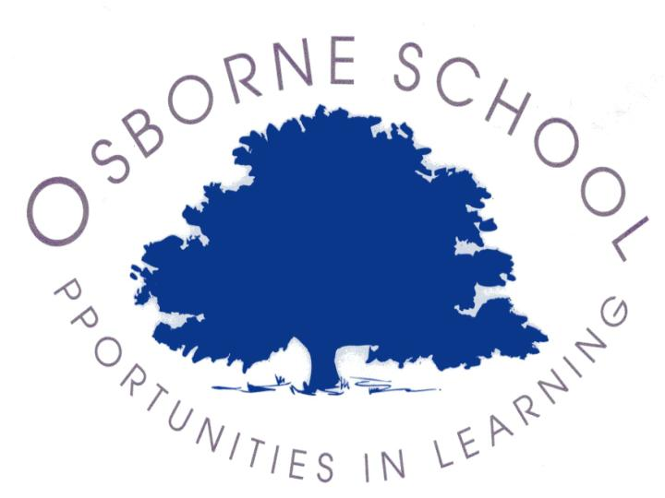
Starting to develop performance skills – Core Task: BTEC Entry 3, Level 1

Vocal skills: eg projection, clarity | Movement skills: eg spatial awareness, coordination | Music skills: eg sense of timing, stage presentation | Dance skills: eg musicality, rhythm
Using the skills below, sort them into the different disciplines. You may need to use the internet to research the meanings of some of the skills if you do not know what they are. Some skills might go in more than one column.
pitch | rhythm | musicality | tone
timing | volume | body shape | body size
expression | speed | flexibility | strength
singing | dancing | beat | clarity
style | genre | balance | expression

