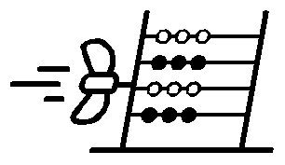Finish the Symmetrical Drawing- Pirate Ship

© Propeller, NR32 2EX, UK
www.propeller.education

EP0319

