|  |  |  |  |
| --- | --- | --- | --- |
|  | Morning | Afternoon | Evening |
| Monday |  |  |  |
| Tuesday |  |  |  |
| Wednesday |  |  |  |
| Thursday |  |  |  |
| Friday |  |  |  |

[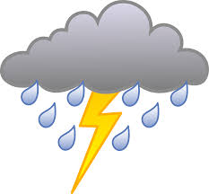](https://www.google.co.uk/url?sa=i&url=https%3A%2F%2Fclipartart.com%2Fcategories%2Fweather-storm-clipart.html&psig=AOvVaw25ySxl4OgWss2cQunfa-Pm&ust=1587474277993000&source=images&cd=vfe&ved=0CAIQjRxqFwoTCNDz4daI9-gCFQAAAAAdAAAAABAD)[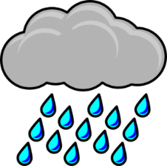](https://www.google.co.uk/url?sa=i&url=http%3A%2F%2Fclipart-library.com%2Frain-cliparts.html&psig=AOvVaw3ubww6HiQ_lluVQwGO3nhv&ust=1587474224727000&source=images&cd=vfe&ved=0CAIQjRxqFwoTCPDovb2I9-gCFQAAAAAdAAAAABAD)[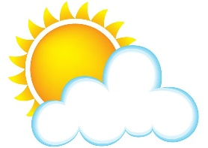](https://www.google.co.uk/url?sa=i&url=https%3A%2F%2Fwww.pinterest.com%2Fpin%2F129830401740497925%2F&psig=AOvVaw2ireZ1iOfYhFu-eRkQ2utg&ust=1587474147312000&source=images&cd=vfe&ved=0CAIQjRxqFwoTCJCslZ2I9-gCFQAAAAAdAAAAABAD)[](https://www.google.co.uk/url?sa=i&url=https%3A%2F%2Fwww.pngitem.com%2Fmiddle%2FbwmRmm_cloud-clipart-fluffy-graphics-illustrations-free-transparent-cloud%2F&psig=AOvVaw3loqtPaBIeTzbHrYdKLFbc&ust=1587473934749000&source=images&cd=vfe&ved=0CAIQjRxqFwoTCNiQh7OH9-gCFQAAAAAdAAAAABAJ)[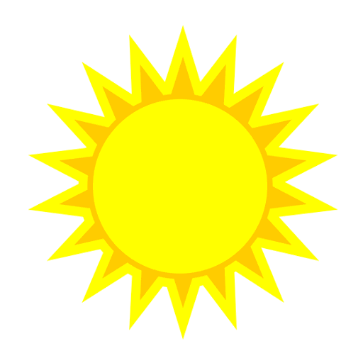](https://www.google.co.uk/url?sa=i&url=http%3A%2F%2Fclipart-library.com%2Ffree-sun-cliparts.html&psig=AOvVaw2DIUz4Sd4bHSuIZMXU32yW&ust=1587473851785000&source=images&cd=vfe&ved=0CAIQjRxqFwoTCLjohIuH9-gCFQAAAAAdAAAAABAD)

**My Weather Record Activity Sheet**

Task: Keep a record of the weather during the week. Draw or stick the weather symbol into the box for each day.

[](https://www.google.co.uk/url?sa=i&url=http%3A%2F%2Fclipart-library.com%2Ffree-sun-cliparts.html&psig=AOvVaw2DIUz4Sd4bHSuIZMXU32yW&ust=1587473851785000&source=images&cd=vfe&ved=0CAIQjRxqFwoTCLjohIuH9-gCFQAAAAAdAAAAABAD)

[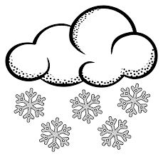](https://www.google.co.uk/url?sa=i&url=https%3A%2F%2Fcliparting.com%2Ffree-snow-clip-art-39395%2F&psig=AOvVaw3sm5xlWkdcEe84pQ4JYM9B&ust=1587474332109000&source=images&cd=vfe&ved=0CAIQjRxqFwoTCOjTlfKI9-gCFQAAAAAdAAAAABAZ)[](https://www.google.co.uk/url?sa=i&url=http%3A%2F%2Fclipart-library.com%2Frain-cliparts.html&psig=AOvVaw3ubww6HiQ_lluVQwGO3nhv&ust=1587474224727000&source=images&cd=vfe&ved=0CAIQjRxqFwoTCPDovb2I9-gCFQAAAAAdAAAAABAD)[](https://www.google.co.uk/url?sa=i&url=https%3A%2F%2Fwww.pinterest.com%2Fpin%2F129830401740497925%2F&psig=AOvVaw2ireZ1iOfYhFu-eRkQ2utg&ust=1587474147312000&source=images&cd=vfe&ved=0CAIQjRxqFwoTCJCslZ2I9-gCFQAAAAAdAAAAABAD)[](https://www.google.co.uk/url?sa=i&url=https%3A%2F%2Fwww.pngitem.com%2Fmiddle%2FbwmRmm_cloud-clipart-fluffy-graphics-illustrations-free-transparent-cloud%2F&psig=AOvVaw3loqtPaBIeTzbHrYdKLFbc&ust=1587473934749000&source=images&cd=vfe&ved=0CAIQjRxqFwoTCNiQh7OH9-gCFQAAAAAdAAAAABAJ)[](https://www.google.co.uk/url?sa=i&url=http%3A%2F%2Fclipart-library.com%2Ffree-sun-cliparts.html&psig=AOvVaw2DIUz4Sd4bHSuIZMXU32yW&ust=1587473851785000&source=images&cd=vfe&ved=0CAIQjRxqFwoTCLjohIuH9-gCFQAAAAAdAAAAABAD)

[](https://www.google.co.uk/url?sa=i&url=https%3A%2F%2Fcliparting.com%2Ffree-rainbow-clip-art-25362%2F&psig=AOvVaw0-TONWKLC2qlo-33VcHnMw&ust=1587474427781000&source=images&cd=vfe&ved=0CAIQjRxqFwoTCIDgrp-J9-gCFQAAAAAdAAAAABAD)[](https://www.google.co.uk/url?sa=i&url=http%3A%2F%2Fclipart-library.com%2Frain-cliparts.html&psig=AOvVaw3ubww6HiQ_lluVQwGO3nhv&ust=1587474224727000&source=images&cd=vfe&ved=0CAIQjRxqFwoTCPDovb2I9-gCFQAAAAAdAAAAABAD)[](https://www.google.co.uk/url?sa=i&url=https%3A%2F%2Fwww.pinterest.com%2Fpin%2F129830401740497925%2F&psig=AOvVaw2ireZ1iOfYhFu-eRkQ2utg&ust=1587474147312000&source=images&cd=vfe&ved=0CAIQjRxqFwoTCJCslZ2I9-gCFQAAAAAdAAAAABAD)[](https://www.google.co.uk/url?sa=i&url=https%3A%2F%2Fwww.pngitem.com%2Fmiddle%2FbwmRmm_cloud-clipart-fluffy-graphics-illustrations-free-transparent-cloud%2F&psig=AOvVaw3loqtPaBIeTzbHrYdKLFbc&ust=1587473934749000&source=images&cd=vfe&ved=0CAIQjRxqFwoTCNiQh7OH9-gCFQAAAAAdAAAAABAJ)[](https://www.google.co.uk/url?sa=i&url=http%3A%2F%2Fclipart-library.com%2Ffree-sun-cliparts.html&psig=AOvVaw2DIUz4Sd4bHSuIZMXU32yW&ust=1587473851785000&source=images&cd=vfe&ved=0CAIQjRxqFwoTCLjohIuH9-gCFQAAAAAdAAAAABAD)