LO: To understand the difference between kinetic and potential energy.

Activity: To build a Catapult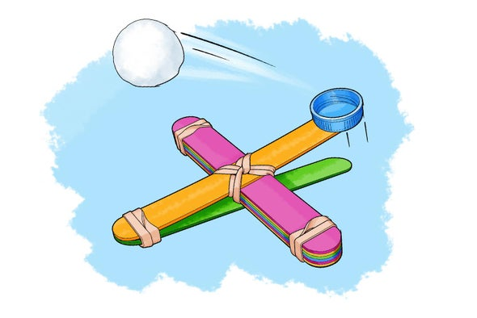

We have been learning about kinetic and potential energy. This experiment can help pupils to understand the difference between kinetic and potential energy. During the operation of the catapult, there are many different forms of energy being transformed into another. ... When the catapult is released, it quickly transforms from potential energy to kinetic energy.
Every object on earth has potential energy. That means it COULD move even if it isn't right now. When an object is moving it has kinetic energy.
Click in the link bellow:
https://kidsactivitiesblog.com/28871/catapult-for-kids-to-make/

