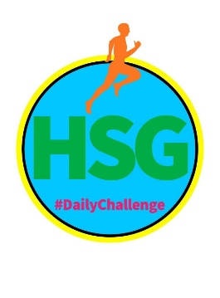

HAMPSHIRE SCHOOL GAMES
SECONDARY PERSONAL BEST CHALLENGE
‘SIT AND REACH’
This week’s challenges all focus on the School Games Values of Determination, Passion, Honesty and Self Belief

Name: Year Group:

School: How far can you reach?

Activity | Description | Number of Reps/ length of time
Warm Up/ Pulse Raiser | Get your pulse up to 130 beats per minute by Jogging, Dancing, Skipping, Hopping | 4 – 5 minutes
Stretch/Mobilise | Full body stretch- go up on tip toes and reach arms as high as possible. Relax and repeat.  Twist to left and right x 5 each side  Gently swing left leg forwards and backwards x 5.  Gently swing right leg forwards and back x 5.  Circle arms forwards x 5 then backwards x 5 | 2 minutes
CARDIO-VASCULAR EXERCISE:  Choose an exercise to get your heart rate up and the blood pumping eg High knees on the spot, skipping |  | 20–30 seconds
LEG EXERCISE:  Choose an exercise to work the legs eg. Lunges, squats, step ups |  | 20 repetitions (10 each leg)
CORE EXERCISE:  Choose an exercise to work your stomach/core muscles eg Sit Ups, Plank, Russian Twists |  | 20 repetitions
CARDIO-VASCULAR EXERCISE:  Choose an exercise to get your heart rate up and the blood pumping eg High knees on the spot, skipping |  | 20-30 seconds
ARM EXERCISE:  Choose an exercise to work your arms eg. Press ups | . | 20 repetitions
CORE EXERCISE:  Eg V Sit | . | Hold for 20 seconds
REPEAT | Repeat the 6 activities above 4 times | 18 - 20 minutes
CHALLENGE | ‘SIT AND REACH’: SIT ON THE FLOOR WITH YOUR LEGS STRAIGHT AND YOUR FEET FLAT AGAINST AN OBJECT THAT WILL STOP YOU FROM SHUFFLING FORWARD EG SOFA, A HELPER’S LEGS. PLACE A RULER AT THE END OF YOUR FEET LEADING AWAY SO THE ‘0’ END IS NEAREST YOUR FEET. REACH FORWARD WITH YOUR HANDS AS FAR AS YOU CAN. HOW MANY CMS CAN YOU REACH?
Challenges should be done between 9am and 3pm – send through your results daily to earn a point for your school. You can take a picture and send it to Emma and Alison at sgoneastleighandwinchester@gmail.com or via twitter @SGO_new. There is also a North Eastleigh and Winchester Facebook page and Hampshire SGO Facebook page where we will be updating the results each day.

