Goose Fair 2017 - Our verdict on brand new thrill ride
Source: https://www.nottinghampost.com/whats-on/whats-on-news/goose-fair-2017-verdict-brand-581300
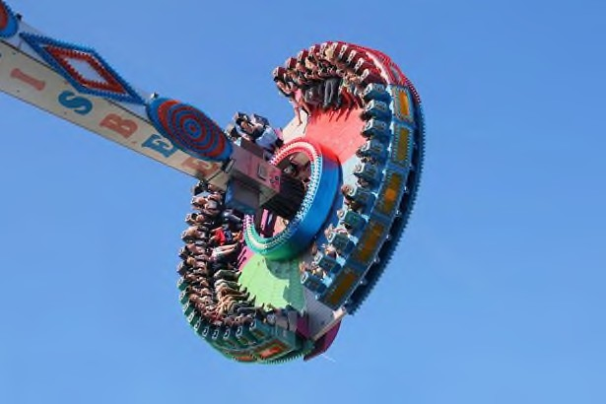
By Rachel Gorman Features Writer, Nottingham Post. 5 Oct 17

Warning: Do not attempt this ride after eating!
Go on, they said, try out the new Goose Fair ride, they said, it won't be that bad, they said, it's basically just a swing, they said. Well, it turns out people lie! Frog-marched to Nottingham's historic funfair with only a tripod and iPhone for company I was tasked with having a go on Goose’s newest offering, the Giant Frisbee.

To put this into context the Giant Frisbee is somewhat of a step up from say the tea cup rides, waltzers or indeed long-term commitment, in terms of fear factor. Shipped over from entertainment complex Global Village Dubai in the Middle East, it's the first time the mega ride
- a huge, swinging disc on which punters sit facing each other as they fly through the air and needs 100 cubic metres of water to counter-balance it – has been on British soil.

Riding the Great Frisbee
In hindsight I was perhaps a little too eager to jump on board meaning there was plenty of time for me to stew on what was yet to come. There was the shame of being more scared than the dozens of children running to their seats, the arm strain of holding a tripod out straight for 15 minutes and the sudden realisation that it wasn't exactly an unlikely possibility that I could drop the tripod and iPhone to its untimely death. Suddenly the lights were on, the music was turned up and the Great Frisbee began to oscillate. The swing started off much like you'd probably remember an old-fashioned pirate ship ride did, until the gondola itself started spinning and then the swing started getting higher and steeper... and higher... and steeper... and higher... and steeper. Repeat ad infinitum. The result was feeling as though you may puke up your stomach, not in a too many candies kind of way, but in a very real possibility that you may lose an internal organ kind of way. It's a memory which will stay with me far beyond this year's clear-up of the fair. Haunt me even. But, hey, at least I didn't drop the camera!

Find out more information at: http://www.nottinghampost.com/whats-on/whats-on-news/goose-fair-2017

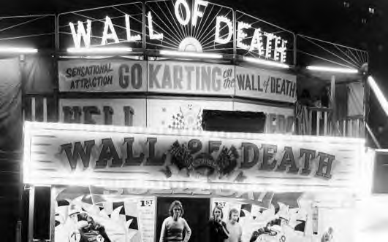
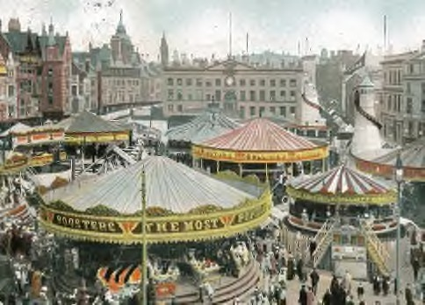
Feel nostalgic with these amazing photos of Nottingham's Goose Fair dating back to the 1920s!

Reading Questions

  - What typical layout features (presentational features) are used to help the reader find the main points?
(Please give examples of at least two layout features.)

(2 marks. L1)

  - What language techniques does the journalist use to outline her experiences of the Goose Fair?
(Please quote examples of two language techniques.)

(2 marks. L2)

  - What would you click to find out more information about the Goose Fair?

(1 mark. L1)

  - What is the dictionary definition of oscillate and what is the subheading of the paragraph it is used in?

(2 marks. L1)

  - What could people look at, if they wanted to feel nostalgic?

(1 mark. L1)

  - Provide a summary of how the journalist felt after riding the Great Frisbee.

(2 marks. L2)

Writing Activity
Your task: Write an article for your local community magazine, to persuade people to visit the Goose Fair and ride the Great Frisbee.
Expand on these points:
- What the Goose Fair has to offer
- The experience of riding the Great Frisbee
- Why this is the perfect place for families to visit
- The positive impact the Goose Fair has on the local community

Remember to use layout features (presentation features) and persuasive devices (language techniques) in your article.

Layout Features | Persuasive Devices
Bold / italics / underlined | Imperative | Fact
Bullets | Hyperbole | Opinion
Colour | Anecdote | Rhetorical Question
Font | Direct Address | Emotive Language
Headline / title / subtitle | Alliteration | Statistics
Headings |  | Triplets
Logo/ image / captions

Plan your work below.

Draft your work here.

Writing Activity Checklist
I have proof read my work
I have written a minimum of one paragraph per bullet point
I have used IHADAFOREST persuasive devices
I have written a minimum of 160 words

Write your final version here.

Functional Skills L1-L2 English mapping
Coverage and range statements provide an indication of the type of content candidates are expected to apply in functional contexts. Relevant content can also be drawn from equivalent (school) National Curriculum levels and the Adult Literacy standards.
- indicates the main coverage and range skills that are (or can be) covered in this resource. However, these will vary with the student group and how the resource is used by the teacher. Reference: Ofqual (2009),
Functional Skills criteria for English: Entry 1, Entry 2, Entry 3, level 1 and level 2. http://www.ofqual.gov.uk/
Level 1 Reading Skill standard (SS): Read and understand a range of straightforward texts
Coverage and range statements
- Identify the main points and ideas and how they are presented in a variety of texts (Q1) ✓
- Read and understand texts in detail (Q4) ✓
- Utilise information contained in texts (Q3) ✓
- Identify suitable responses to texts (Q5) ✓
Level 1 Writing (SS): Write a range of texts to communicate information, ideas and opinions, using
formats and styles suitable for their purpose and audience
- Write clearly and coherently, including an appropriate level of detail ✓
- Present information in a logical sequence ✓
- Use language, format and structure suitable for purpose and audience ✓
- Use correct grammar, including correct and consistent use of tense ✓
- Ensure written work includes generally accurate punctuation / spelling and that meaning is clear ✓
Level 2 (SS): Select, read, understand and compare texts and use them to gather information,
Reading ideas, arguments and opinions
- Select and use different types of texts to obtain and utilise relevant information ✓
- Read and summarise, succinctly, information/ideas from different sources (Q6) ✓
- Identify the purposes of texts and comment on how meaning is conveyed (Q2) ✓
- Detect point of view, implicit meaning and/or bias
- Analyse texts in relation to audience needs and consider suitable responses
Level 2 Writing (SS): Write a range of texts, including extended written documents, communicating
information, ideas and opinions, effectively and persuasively
- Present information on complex subjects clearly and concisely ✓
- Present information/ideas concisely, logically, and persuasively ✓
- Use a range of writing styles for different purposes ✓
- Use a range of sentence structures, including complex sentences, and paragraphs to organise written communication effectively ✓
- Punctuate written text using commas, apostrophes and inverted commas accurately ✓
- Ensure written work is fit for purpose and audience, with accurate spelling and grammar that supports clear meaning ✓
* This resource also covers many adult literacy curriculum http://www.excellencegateway.org.uk/content/etf1286 elements

Sample answers – others may be possible. Check with your tutor.

- What typical layout features (presentational features) are used to help the reader find the main points?
Bold text, underlined text, headline/ sub-headings.
- What language features does the journalist use to outline her experiences of the Goose Fair? Triplets / repetition for emphasis (higher and steeper …)
Humour (Hey … didn’t drop the camera! Do not attempt this ride after eating!);
Personification (drop the … phone to its untimely death);
Hyperbole / exaggeration (Frog-marched to Nottingham, lose an internal organ).
Statistics (needs 100 cubic metres of water to counterbalance it).
Facts (Shipped over from…Dubai in the Middle East]
- What would you click to find out more information about the Goose Fair? The web link at the end of the article.
- Dictionary definition of oscillate? What is the subheading of the paragraph it is used in?
To move or swing back and forth in a regular rhythm. Riding the Great Frisbee.
- What could people look at, if they wanted to feel nostalgic?
The photos at the end of the article.
- Provide a summary of how the journalist felt after riding the Great Frisbee.
Example summary.
The journalist felt scared waiting for the ride to start. Her arm ached from constantly holding her iPhone out at arm’s length. She felt very sick due to the constant repetitive swinging.

I HAD A FOREST persuasive devices
I m p e r a t i v e
H y p e r b o l e
A l l i t e r a t i o n
D i r e c t A d d r e s s
A n e c d o t e
F a c t
O p i n i o n
R h e t o r i c a l Q u e s t i o n
E m o t i v e L a n g u a g e
S t a t i s t i c s
T r i p l e t s ( R u l e o f T h r e e )

