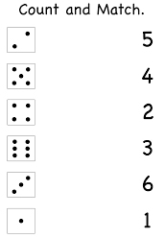
Count and match numbers to correct amount.

