**I can solve word problems**

* MyMaths <https://login.mymaths.co.uk/>

Logon: Osborne Password: square

* Please find

,  and  Activities below



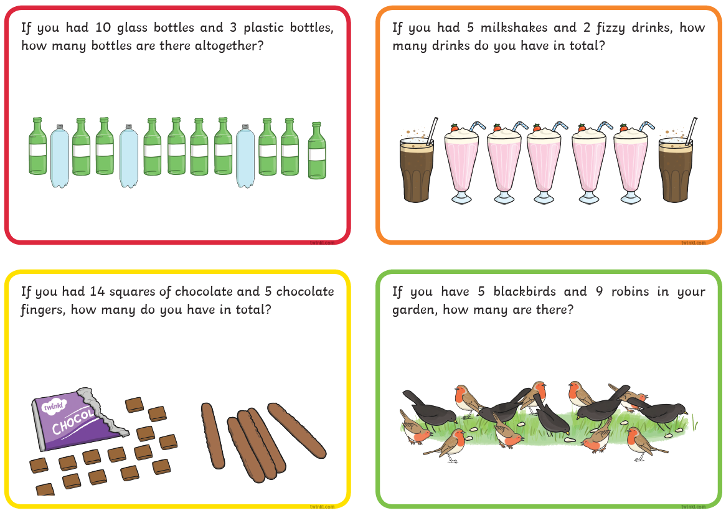

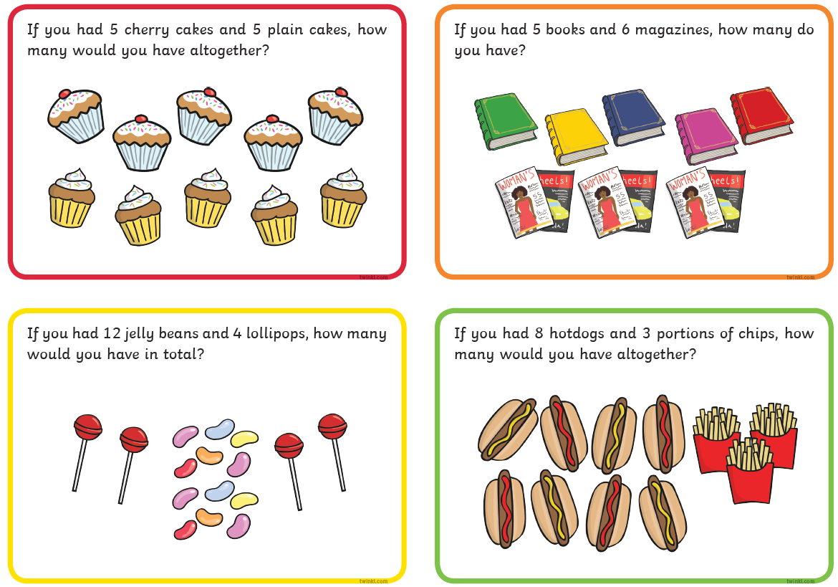

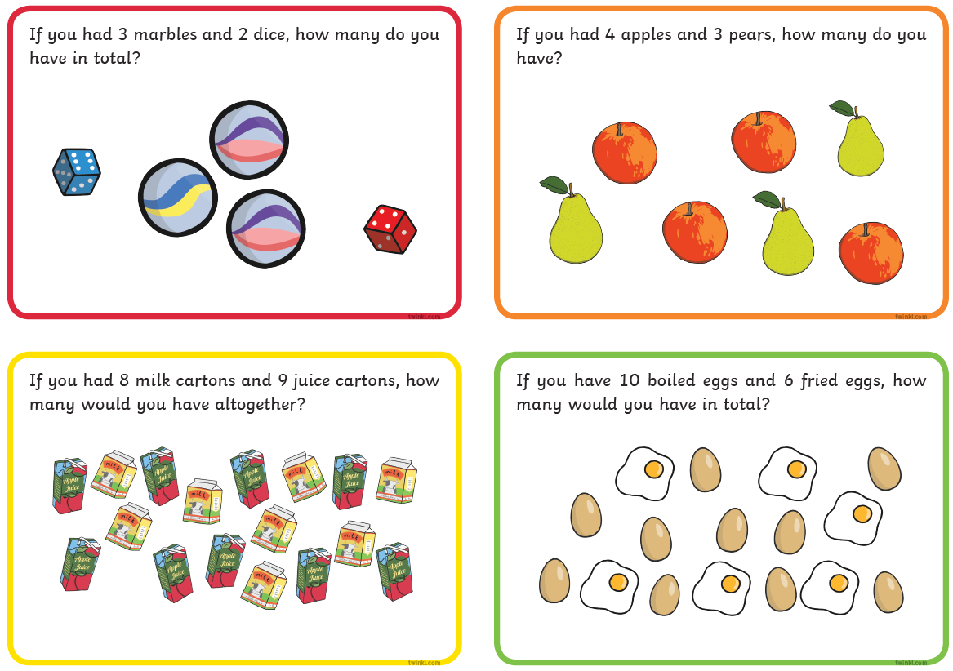



There a 4 children on the bus. Another 2 children get on. How many children are there now on the bus?

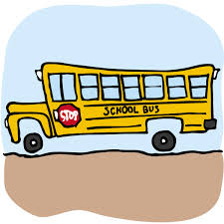

Tom has 5 cakes. He give 1 to Sarah and 1 to Bill. How many have they got altogether?



I eat 2 apples at snack time and 2 apples at lunch time. How many apples have I eaten altogether?

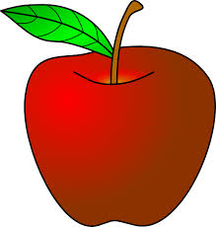

I have 10 bananas and I give 8 to the monkeys. How many do I have left?

