Task: Create a powerpoint about Anne Frank and her family.

Include: 1) Pictures of Anne and her family and the annexe they were hiding in.
2) Information about Anne; when and where she was born.
3) Name and age of her sister.
4) Name and occupations of her mother and father.
5) When and where they went into hiding.

Any other interesting information you would like to add about Anne and her family.

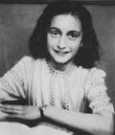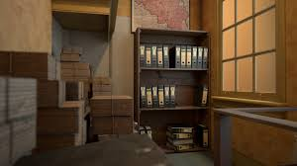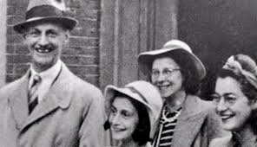

If you have time and would like to take part in a short quiz about Anne Frank click on this link:
https://www.slideshare.net/Qwizdom/anne-frank-quiz

