Energy
Key Stage 3 Science
LO: Recognise different types of energy and describe how energy can be transferred from one type to another.

1)Some of the statements in the table are true some are false. Write the word true or false next to each statement.
Statement | True or False
There are 9 types of energy
Energy can be created
Energy can be destroyed
Energy can be changed from one type to another.
Energy can be stored

2) Label the main type of energy each of these pictures represents. Which type is missing?
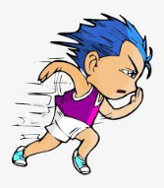
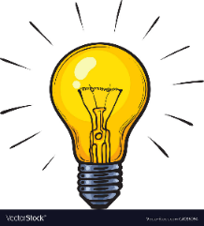

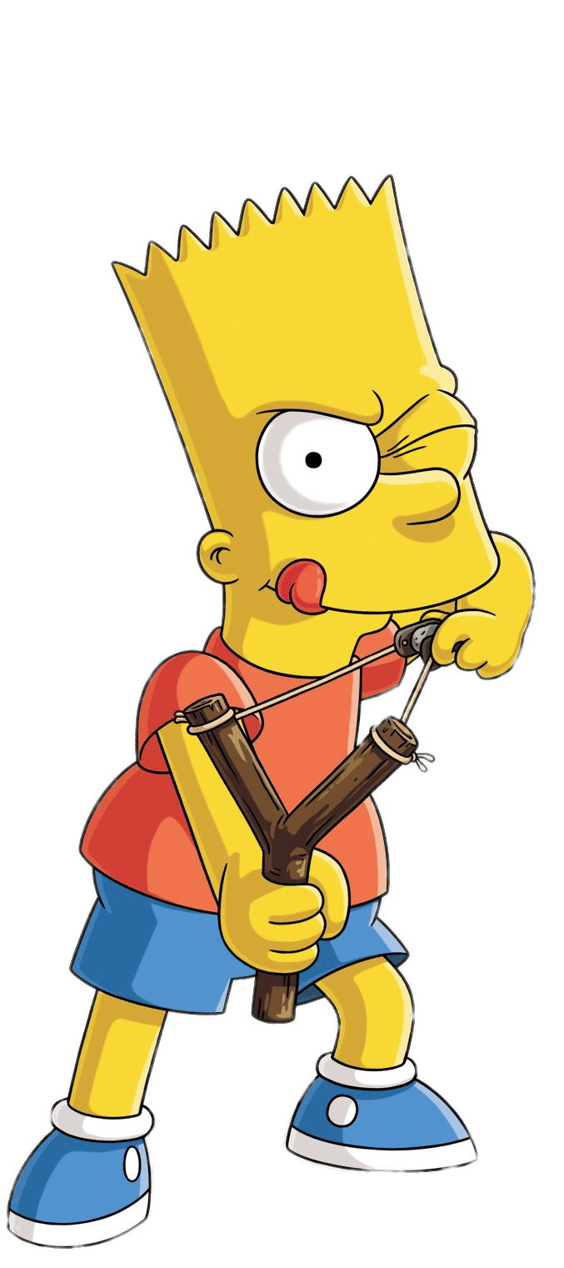
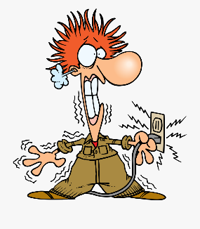

Heat
Gravitational potential
Elastic
Nuclear
Sound
Light
Kinetic
movement

Electrical
Chemical
3) Label what type of energy is put in and what type or types come out.

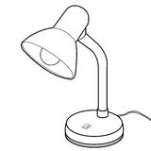

Electric Light

Television

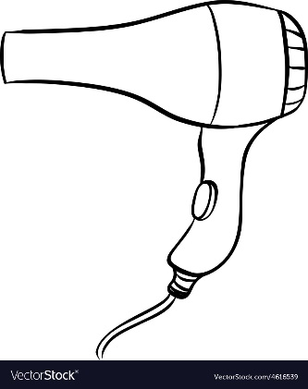
Hairdryer

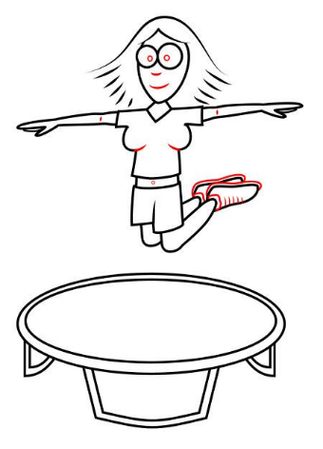
Jumping on a trampoline

4) This car transfers chemical energy in the petrol into other types of energy. Which energy is useful and which energy is wasted?
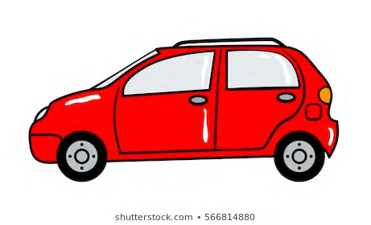
Sound energy
Heat energy
Petrol Car
Chemical energy
Kinetic energy
movement

