Organs and Systems
Key Stage 4 Science ELC/GCSE
LO: Explain the terms organ and organ system and describe some of the major organs and organ systems in the human body.
1) Put these in the correct order from smallest to largest.
Tissue
Cell
Organ system
Organism
Organ

2) Label the organs in this diagram.
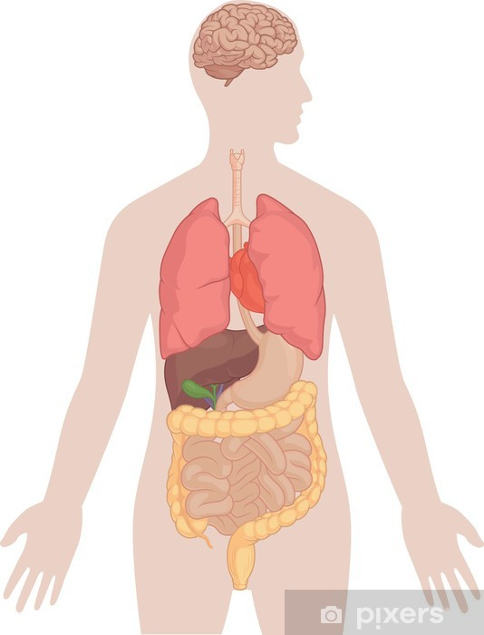

3) Compete the table to give the function of each organ.
Organ | Function
Brain | Control the whole body.
Heart

Lungs

Stomach

Kidneys

4) Match the organ to the organ system
Digestive system
Brain

Respiratory system
Heart
Central nervous system
Lungs

Urinary system
Stomach
Circulatory system
kidneys

5) Fill in the missing words. There may be more than one word that could fit the gap.
All organisms are made of . Some organisms are just one cell, such as . Humans are multicellular so have many different kinds of cell. Groups of cells form such as muscle. Groups of these tissues form such as the . Groups of organs work together to form organ such as the system.

