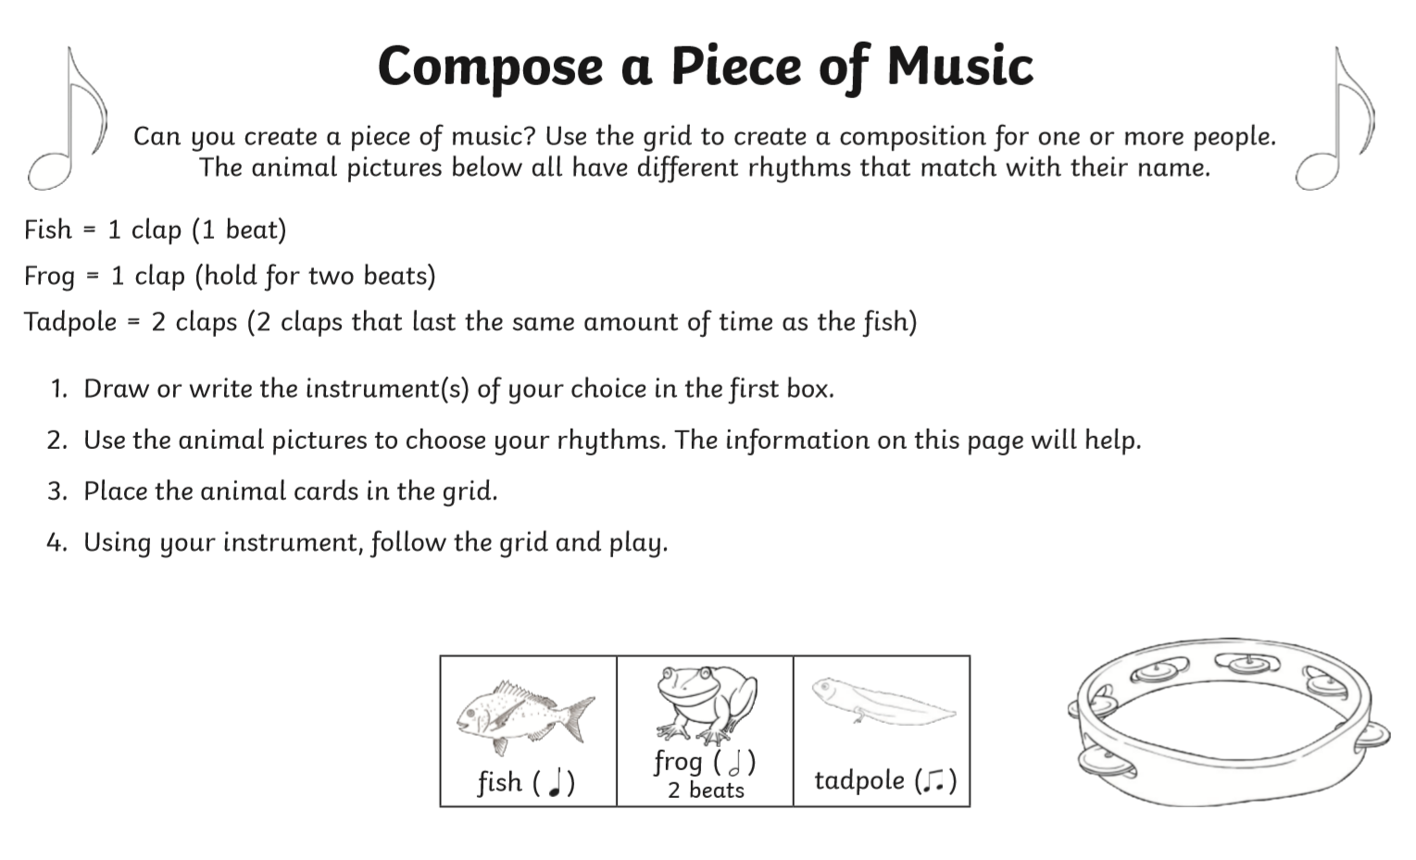

Performing Arts BTEC Entry 3 Core Activity 4.5.20

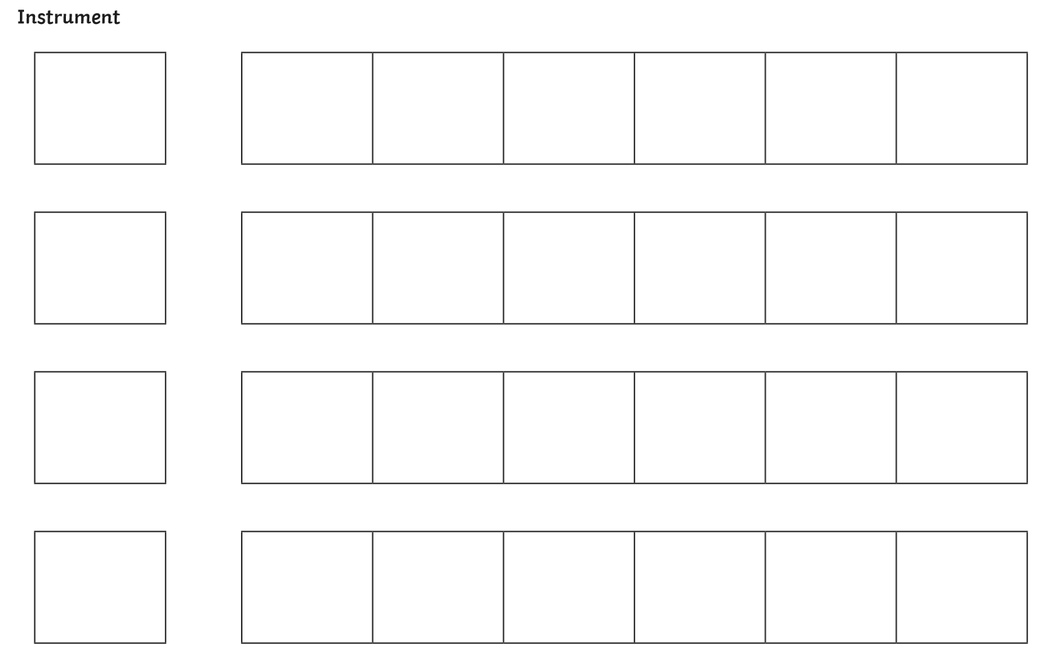

**Composition**

Choose a musical instrument you may have at home, make your own using this week’s ‘Make and Instrument’ activity, or use your hands to clap. Stick, draw or write the animals (fish, frog, tadpole) in the boxes below to compose your own piece of music.

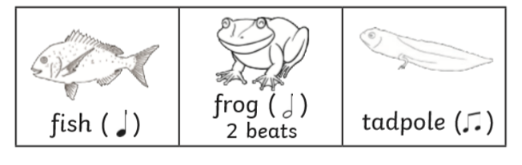

Use these animal pictures for your composition. If you need more pictures, you can print out this page as many times as you like.

If you don’t have a printer, you could draw the composition grids on a piece of paper and then draw or write the animals in.