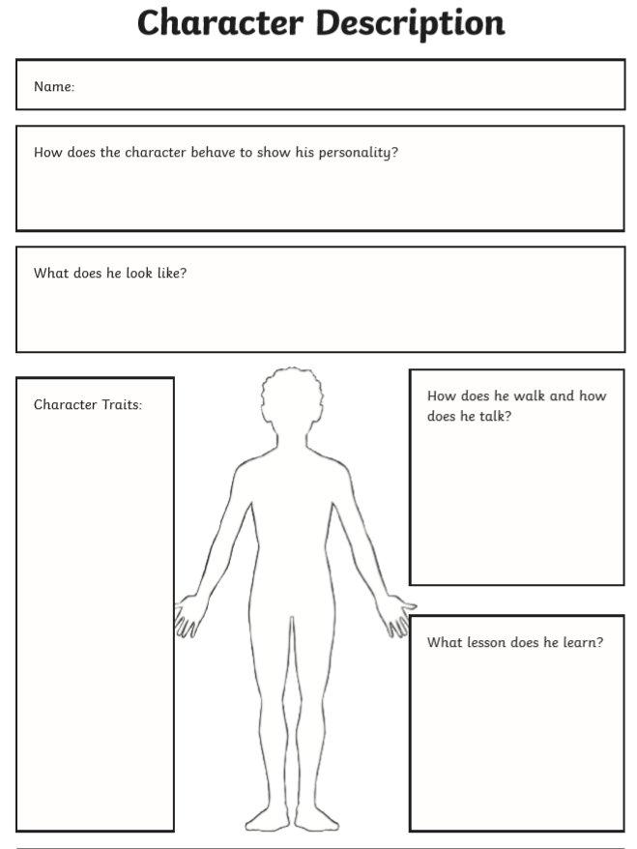

After watching the videos from Cirque Du Soleil, think about one of the characters or design a character of your own using the template below: