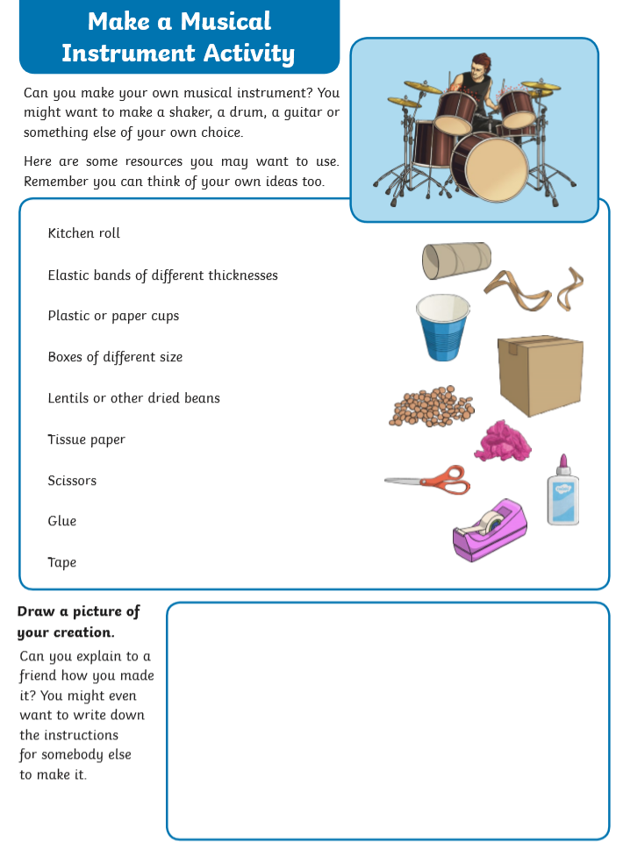

Performing Arts – All levels fun activity 4.5.20