Make a pressed flower mobile
Enjoy time in the garden and make the space even prettier with this fun mobile inspired by nature.
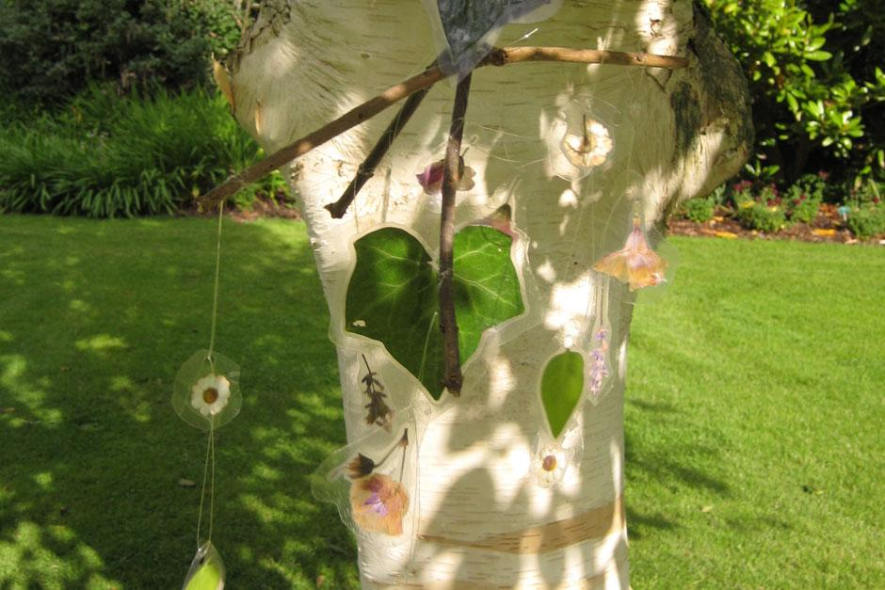

What you'll need
- 2 or 3 sticks
- Collected flowers or leaves
- Sticky tape
- Clear plastic thread (such as fishing line)
- Sticky back plastic
- 3 large hardback books
- Paper towels
- Cardboard
- Hole punch

What to do
- In your garden find some brightly coloured flowers and unusual-shaped leaves. Don’t forget to ask a grown-up which flowers and leaves you are able to pick. You will need at least 12 items. You could choose to collect a rainbow of colours from different plants, or keep to just one colour.
- On a large hardback book place a piece of cardboard. Spread out a paper towel on top and lay out all your flowers or leaves so that they don’t touch each other. Cover with a paper towel and then cover that with another piece of card and lay at least two heavy hardback books on top.
- Be patient - you will need to leave the flowers or leaves for about two weeks! While you wait, you can design your mobile shape.
- This next part is tricky and you will need to ask an adult to help. First of all cut two pieces of sticky back plastic to the same size but slightly larger than your flower (or leaf). Unpeel one and ask an adult to hold the plastic in place while you put your flower on the sticky side. Then, as they are still holding, peel your second piece of plastic and place it sticky side down on to the flower. Now you can cut the plastic to shape. Make sure you leave an edge of around 1cm all around the flower so that it stays dry in the rain.
- When you have done this to all the flowers, punch a hole in the top of each and thread a length of clear thread or ribbon through each one. They look good if they are different lengths so that they hang at different heights.
- Take the sticks and tie them together in a cross or a star shape and attach threaded flowers to each corner. Tie a long thread to the centre and hang the mobile from a tree in your garden and you will have flowers all year round.

