Respiration
Key Stage 4 – Entry Level
LO: Describe what respiration is and recall the word equation.

1) Fill in the missing words.
Respiration is ____ the same a breathing. Breathing happens in our ________. We breathe in ________ and breathe out carbon _________.
Respiration happens in every ____ in the body. It is a chemical _________. Oxygen reacts with a type of _______ called glucose to release energy. We get glucose from our _______. This reaction produces carbon dioxide and ________.

oxygen sugar water cell lungs reaction food dioxide not

2) Write the word equation for respiration.

_____________ + ____________ →___________ + __________

3) Some of the statements below are true and some are false. Write true or false next to each statement to show this. The first has been done for you.
Respiration is the same as breathing. False
We use our lungs to breathe.
We breathe in carbon dioxide and breathe out oxygen.
Respiration happens in every cell in our bodies.
Respiration releases energy from our food.
Respiration uses a simple sugar called starch.
Carbon dioxide is good for our bodies.

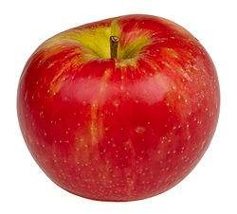
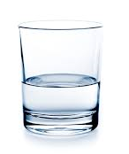
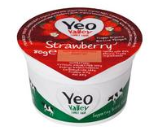
4) Sugar contains lots of energy. Put these in order from the lowest to the highest energy.
Water
Large Chocolate Bar
Fruit Yogurt
Apple

5) Match the first half of the sentence on the left to the second half on the right. The first one has been done for you.
Respiration is not |  | oxygen to release energy.
Respiration happens in |  | are produced.
Glucose reacts with |  | the same as breathing.
Carbon dioxide and water |  | simple sugar.
Glucose is a type of |  | every cell in our body.

