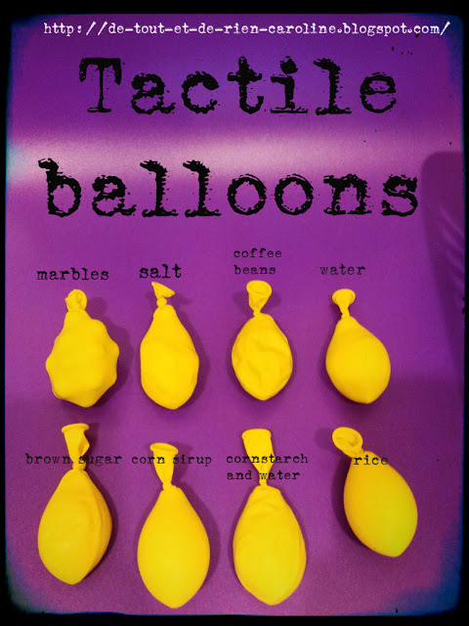

Each balloon contains a different material. Students use the 4 senses. Touch with different textures, sight by observing the shape and size of the ingredients through the balloons, smell especially with the coffee beans and the sense of hearing - sounds that occur when ingredients are rubbed together.
You may use as many balloons as you wish, here I used 8. The material I used: whole coffee beans, rice, sugar, corn syrup, water, marbles, corn starch with water and salt. My favourite tactile balloon is the one that contains corn starch and water: the texture is similar of a stress ball.

