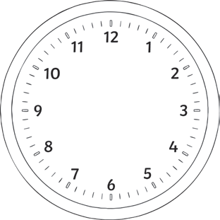
Converting Time Between Digital
and Analogue Clocks
1. Convert the following times on these analogue clocks to digital time.

a) b)

c) d)

e) f)

Converting Time Between Digital

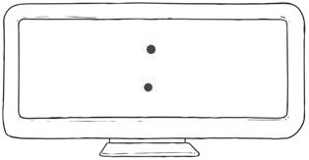
Page 1 of 2
Converting Time Between Digital and Analogue Clocks

2. Draw the following times on these clock faces.

a) b)

c) d)

e) f)

visit twinkl.com
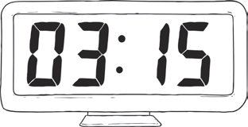
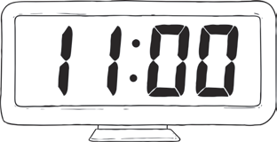
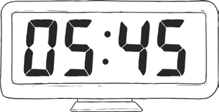
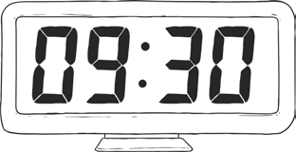
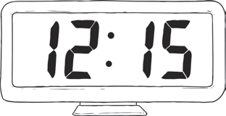
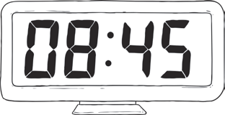
Page 2 of 2
Converting Time Between Digital and
Analogue Clocks Answers

1.

a)
1.

a)
05:30 also accept 17:30 b)
1.

a)
1.

a)

d) 08:00 also accept 20:00 e) 04:45 also accept 16:45 f) 11:15 also accept 23:15

2.

c)
1.

a)

d) e) f)

visit twinkl.com
b)
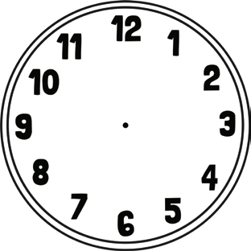
Converting Time Between Digital
and Analogue Clocks
1. Convert the following times on these analogue clocks to digital time.

a) b)

c) d)

e) f)

Converting Time Between Digital

Page 1 of 2
Converting Time Between Digital and Analogue Clocks

2. Draw the following times on these clock faces.

a) b)

c) d)

e) f)

visit twinkl.com
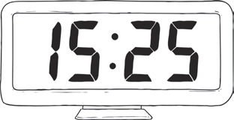
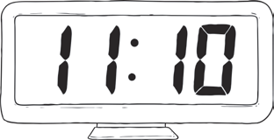
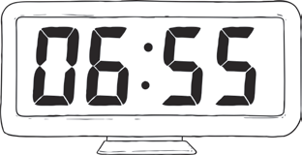
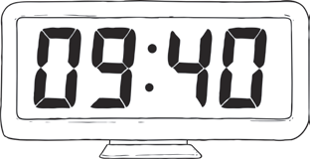
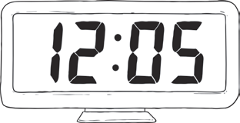
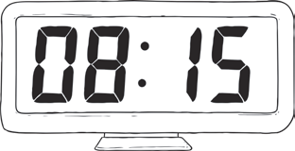
Page 2 of 2
Converting Time Between Digital and
b)
Analogue Clocks Answers

1.

a)
1.

a)
05:25 also accept 17:25 b)
1.

a)
1.

a)

d) 08:05 also accept 20:05 e) 04:20 also accept 16:20 f) 11:35 also accept 23:35

2.

c)
1.

a)

d) e) f)

visit twinkl.com
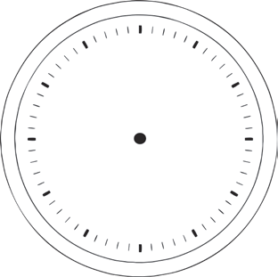
Converting Time Between Digital
and Analogue Clocks
1. Convert the following times on these analogue clocks to digital time.

a) b)

c) d)

e) f)

Converting Time Between Digital

Page 1 of 2
Converting Time Between Digital and Analogue Clocks

2. Draw the following times on these clock faces.

a) b)

c) d)

e) f)

visit twinkl.com
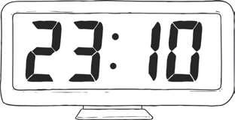
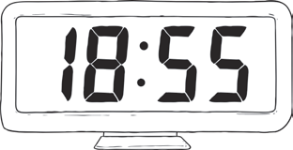
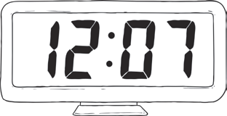
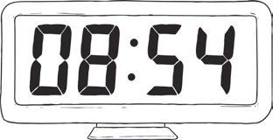
Page 2 of 2
Converting Time Between Digital and
Analogue Clocks Answers

1.

a)
1.

a)
05:25 also accept 17:25 b)
1.

a)
1.

a)

d) 08:05 also accept 20:05 e) 04:22 also accept 16:22 f) 11:37 also accept 23:37

2.

c)
1.

a)

d) e) f)

visit twinkl.com
b)

