Cup Cakes

- Preheat the oven to 180 degrees.

- Lay out 12 cake cases in a tray.

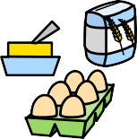
- Weigh out the ingredients.

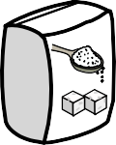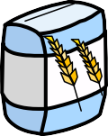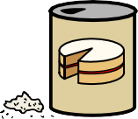
- Mix the sugar, flour and baking powder.

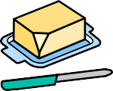
- Add the butter and eggs.

- Whisk it all together.

- Fill up the cake cases.

Cup Cakes Ingredients List

2 eggs

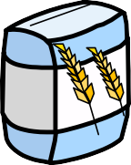
110g (4oz) self-raising flour

110g (4oz) butter

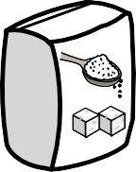
110g (4oz) caster sugar

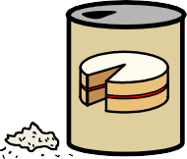
2 teaspoons baking powder
