LO: Develop your knowledge of the author Roald Dahl, his books and poems.

Watch the video at this link to give you some information about Roald Dahl.

<https://www.bbc.co.uk/newsround/35579345>

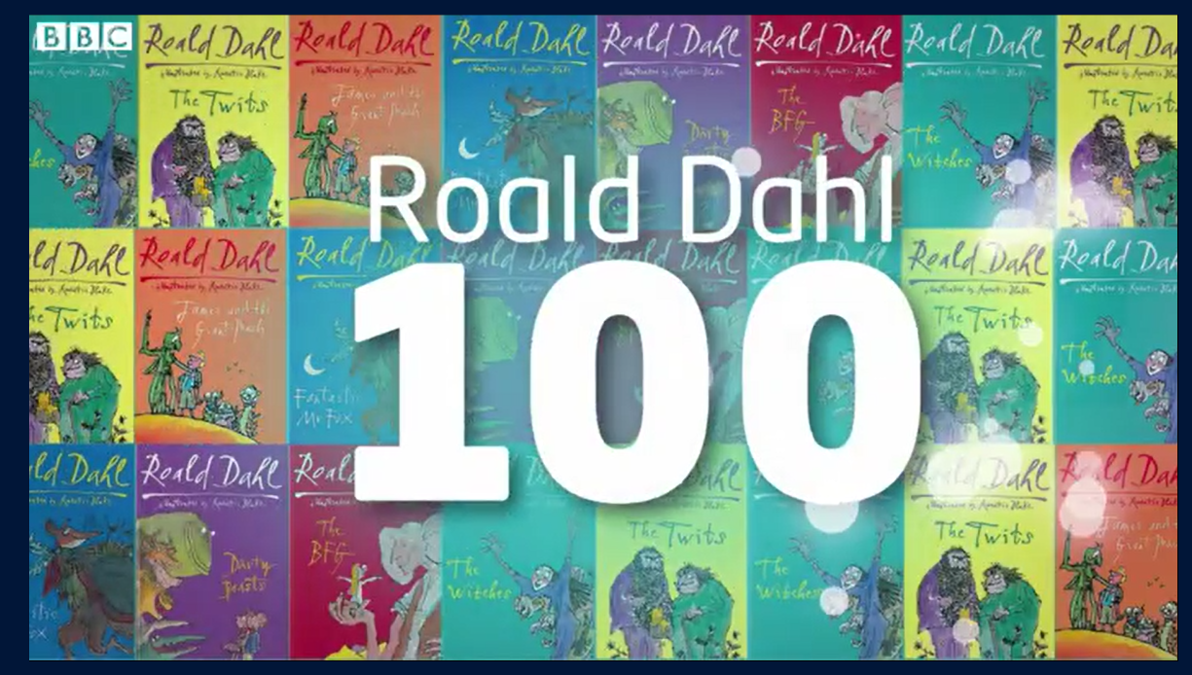

Next, read throughout the PowerPoint that has been sent with your weekly activities:

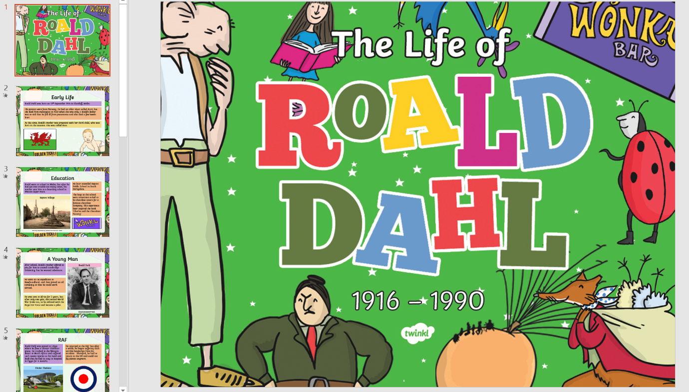

Read this information sheet or ask someone to help you read it. Once you have finished, answer the questions.

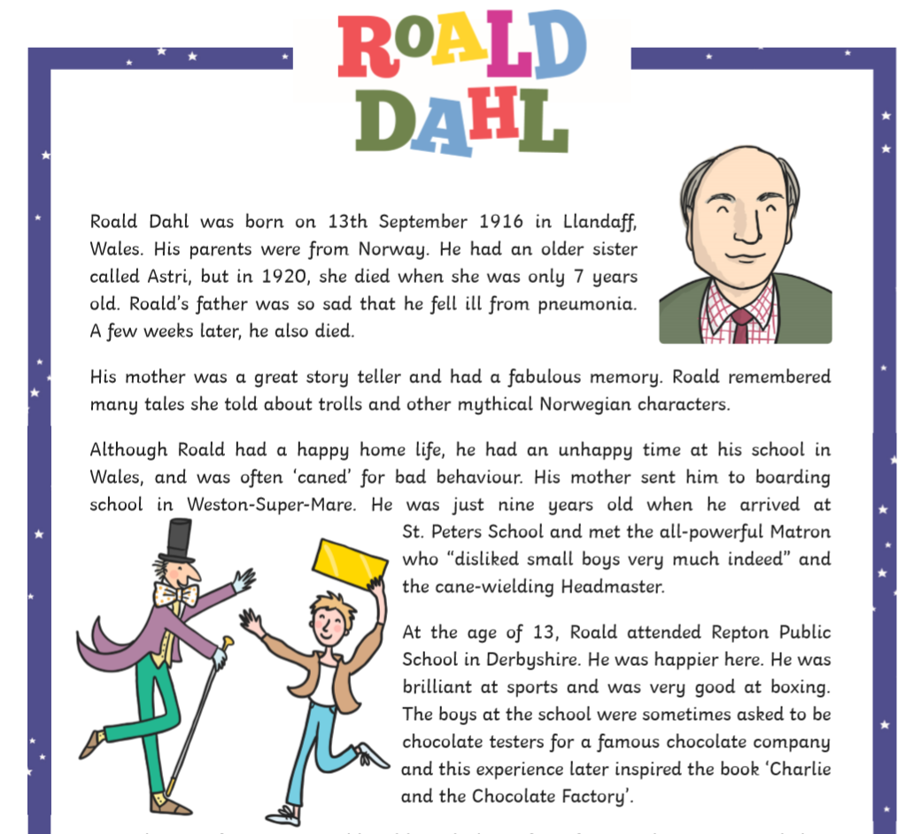

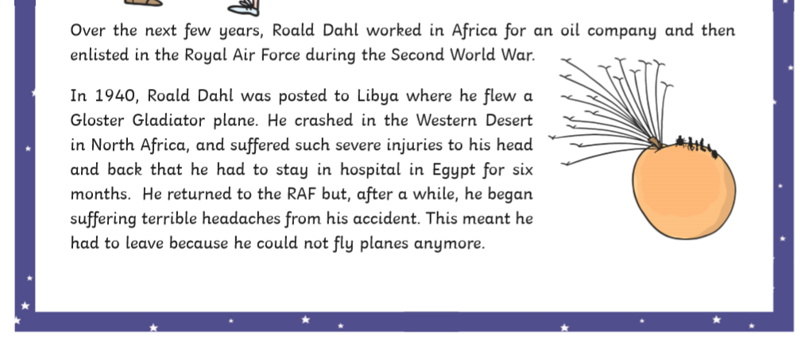

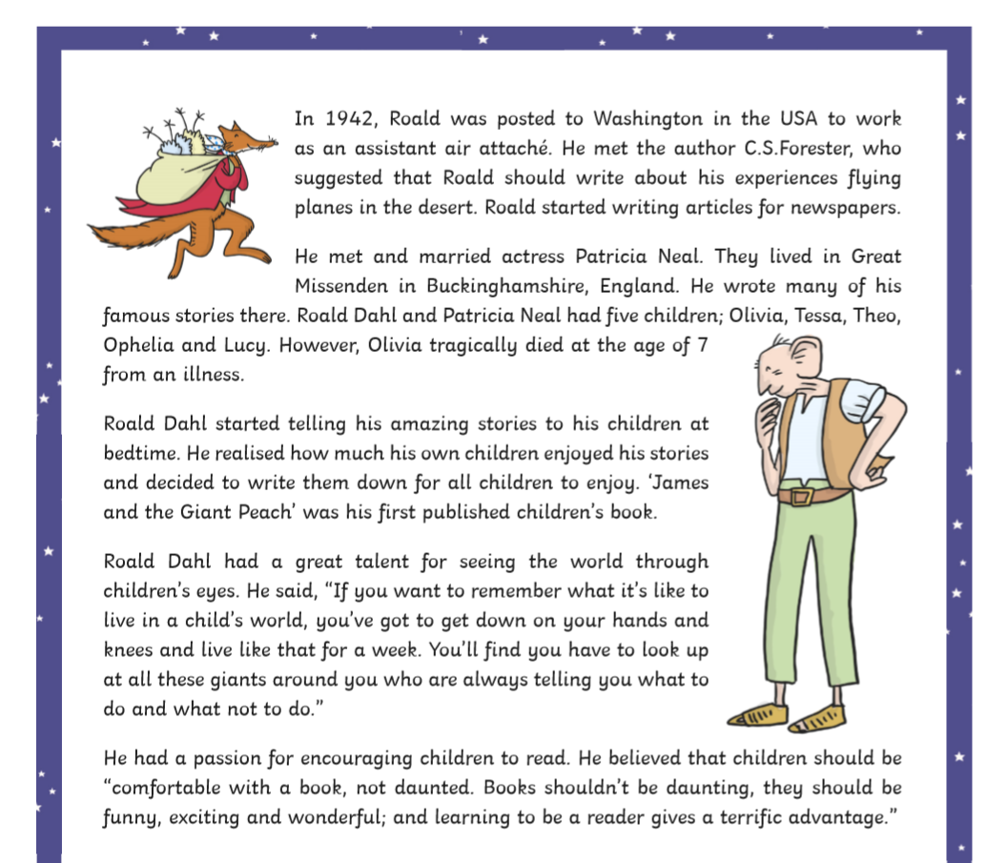



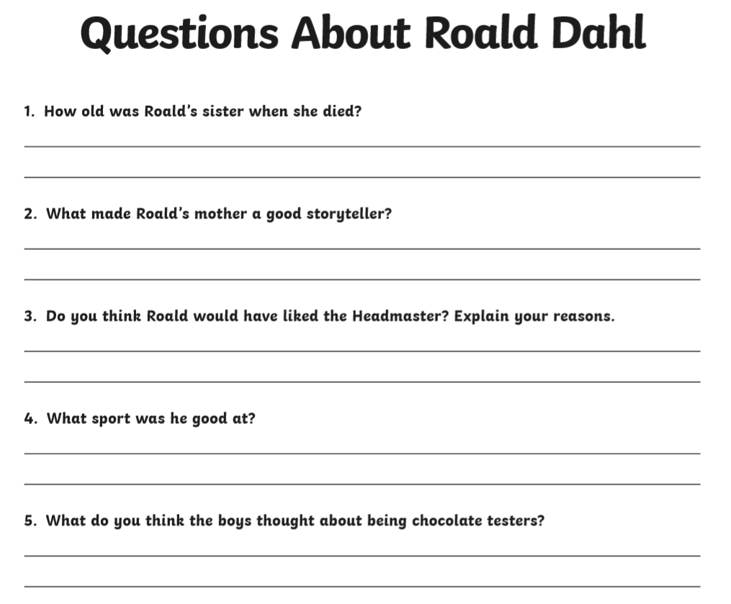

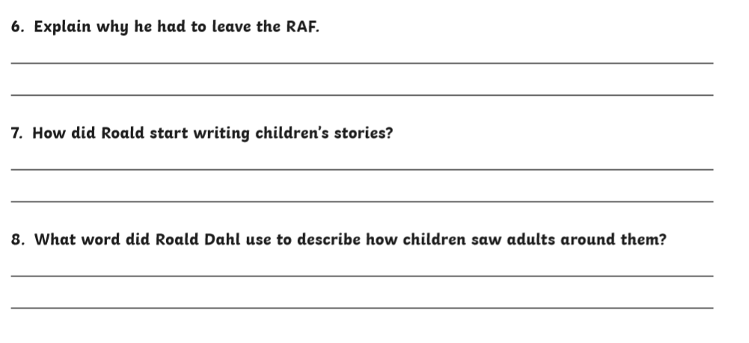

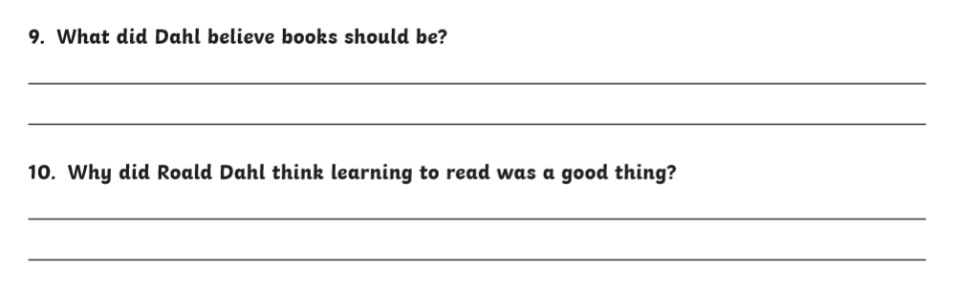

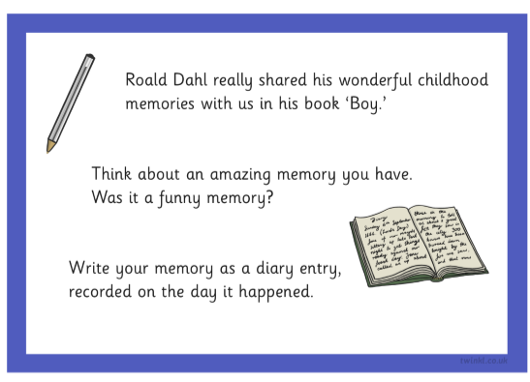

Roald Dahl Challenges. Here are two challenges to complete:

