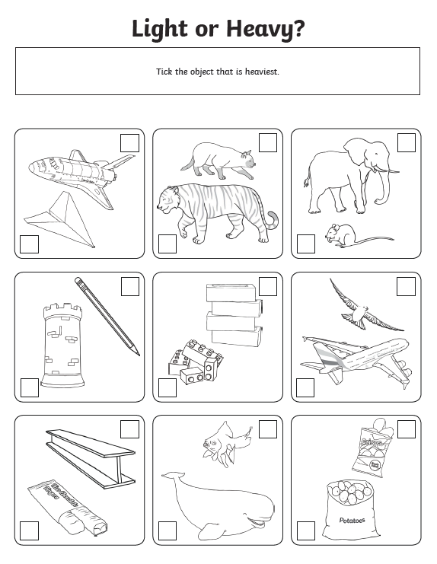

Let the students explore heavy and light objects around the house. Let them see if they could label heavy or light.

Number bingo 1-10 in order
1 | 2 | 3 | 4 | 5
6 | 7 | 8 | 9 | 10

Number bingo 1-10 randomised

8 | 1 | 6 | 4 | 10
3 | 7 | 2 | 9 | 5

Number bingo – Make your own version for numbers beyond 10

8 | 1 | 6 | 4 | 10
3 | 7 | 2 | 9 | 5

