- Wall Target
How to –
- Challenge members of your family to see who can get closest to the wall without touching it!
- You can use a pair of rolled up socks or a bean bag or soft tot
- Decide what distance to start from the wall
- Send your item by throwing, pushing, kicking
- If your item hits the wall it cannot count
- See who can get to 5 points first!

Equipment – pair of socks or soft toy or bean bag

Skill related focus – Target

Points system – Every time you get closest to the wall you score a point. Who can get to 5 points first!

WALL TARGET
Score sheet

Name | Points tally | Final score

- Slalom Course
How to –
- Select 6 items to act as markers
- Set them out in the garden or in a room at least 1m apart
- Choose someone to time you
- Travelling in a figure of 8 how long does it take you to move in and out of the 6 markers and back
- Try this 3 times and try to beat your score
- If you find this easy try balancing something on your head and try again!
Equipment – 6 items to act as markers (cans, toys, books, cones) a stopwatch
Skill related focus – Agility
Points system – Give yourself 1 point if you beat your best score. Give yourself 3 points if you beat your best score for a second time. Give yourself 5 points if you managed to do it balancing something on part of your body
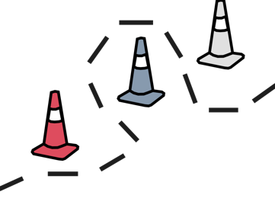

SLALOM COURSE

Score sheet

Name | Time 1 | Time 2 | Time 3

- Soccia
How to –
- Challenge a member of your family to play against
- Each person will need 6 socks folded into a ball shape and ideally of different colours (player 1 has 6 red socks, player 2 has 6 blue socks)
- Choose a white item to become the target or ‘Jack’
- Decide who is going first. They will choose where to place the target.
- Take it in turns to see who can get their sock closest to the target
- Whoever is closest scores a point.
- Challenge different people or play the game three times
Equipment – 6 socks of the same colour, 6 socks of a different colour. A target
Skill related focus – Target and Cognitive Skills
Points system – 1 point if only 1 of your socks is closest to the target. 2 points if 2 of your socks are closest to the target etc

SOCCIA

Score sheet

Name | Game 1 | Game 2 | Game 3

- Treasure Hunt
How to –
- Ask a member of your family to hide 5 items in a room or in the garden
- Ask them to take a picture of the items or draw a picture of what you are looking for
- Once the items are hidden, ask them to start you off and time how long it takes you to find all five items
- Once finished, record your score
- Ask them to hide the same items in different places or choose 5 different items to hide
- Can you beat your time?
- Can you beat any of your family members times?
Equipment – 5 items to hide, picture or photo of the items, stopwatch
Skill related focus – Cognitive and Physical Skills
Points system – 1 point if you beat your time, 3 points if you beat a family members time!

TREASURE HUNT

Score sheet

Name | Game 1 | Game 2 | Points

