Communicate one way to help a friend.
You see a friend sad / angry from being bullied. What can we do to help them?
For research use https://www.childline.org.uk/info-advice/friends-relationships-sex/friends/helping-friend/

Idea 2
Idea 1

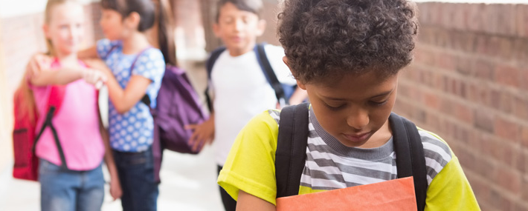

Idea 4
Idea 3

