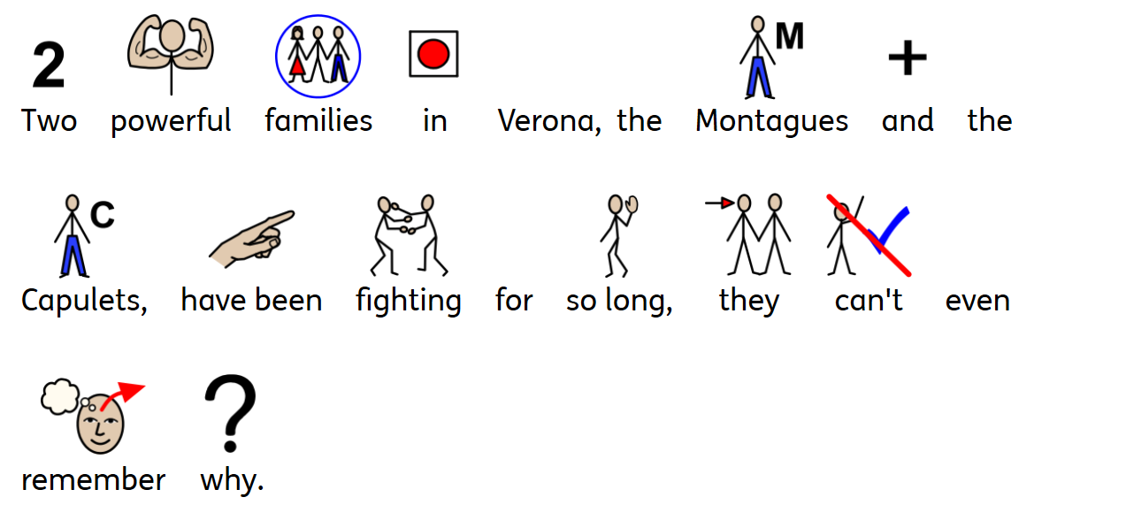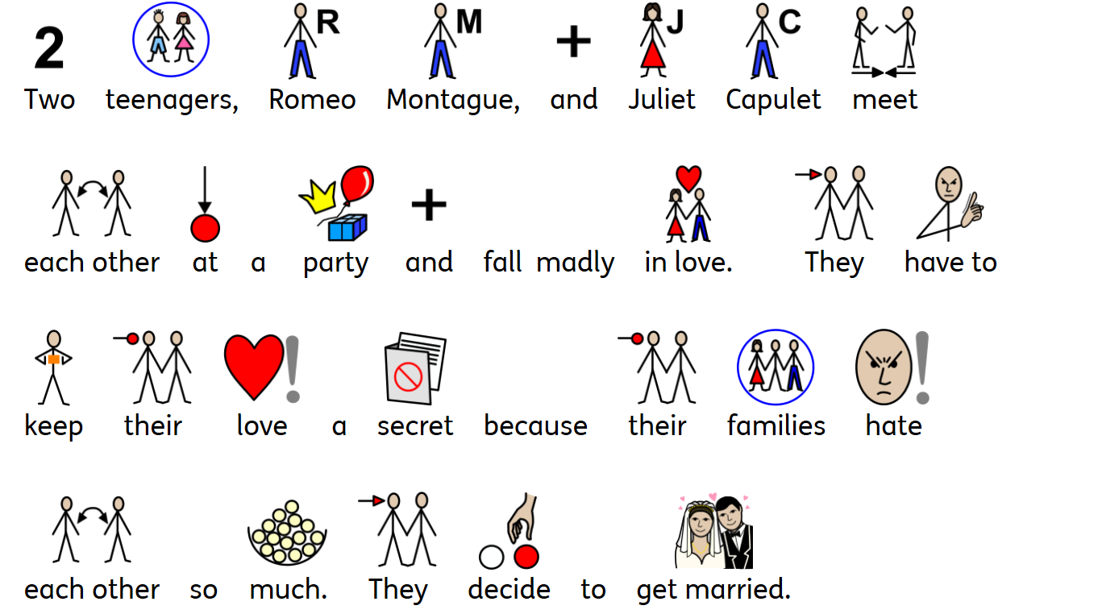

Shakespeare Schools Foundation are celebrating all things Shakespeare in their ‘Summer of Shakespeare’. In Autumn 2020, we will be working on Romeo and Juliet in more detail. To get us prepared, either read through the story below or ask someone to help you read it, and then complete the film poster activity.

