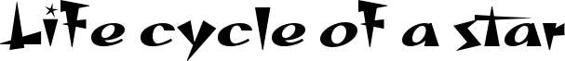
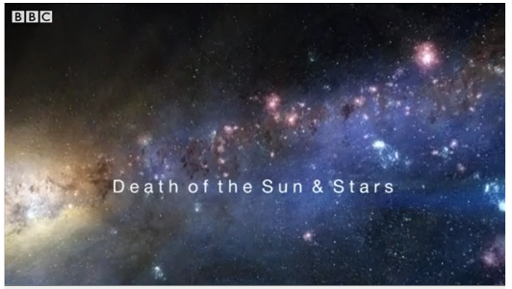
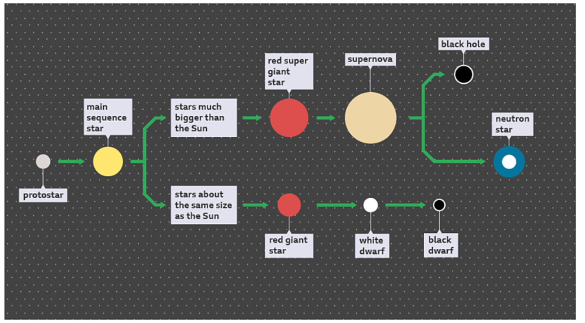
All stars (including the Sun) go through a life cycle, where they are born and eventually die.
Watch this video where Professor Brian Cox explains this life cycle:
https://www.bbc.co.uk/bitesize/articles/zm4r47h

The formation and life cycle of stars:
The life cycle for a particular star depends on its size. The diagram below shows the life cycles of stars that are:
- 1) about the same size as the Sun
- 2) far greater than the Sun in size

Type of star | Description
A nebula | A star forms from massive clouds of dust and gas in space, also known as a nebula. Nebulae are mostly composed of hydrogen.  Gravity begins to pull the dust and gas together.
Protostar | As the mass falls together it gets hot. A star is formed when it is hot enough for the hydrogen nuclei to fuse together to make helium. The fusion process releases energy, which keeps the core of the star hot.
Main sequence star | For most of its lifetime, a star is a main sequence star. It is stable, with balanced forces keeping it the same size all the time.  During this period:  - 1) gravitational attraction tends to collapse the star  - 2) radiation pressure from the fusion reactions tends to expand the star  - 3) forces caused by gravitational attraction and fusion energy are balanced  The Sun is expected to be a main sequence star for billions of years.
Red giant star | When all the hydrogen has been used up in the fusion process, larger nuclei begin to form and the star may expand to become a red giant.
White dwarf | When all the nuclear reactions are over, a small star like the Sun may begin to contract under the pull of gravity.  In this instance, the star becomes a white dwarf which fades and changes colour as it cools.
Supernova | A larger star with more mass will go on making nuclear reactions, getting hotter and expanding until it explodes as a supernova.
Neutron star or black hole | Depending on the mass at the start of its life, a supernova will leave behind either a neutron star or a black hole.
Click on this link and scroll almost to the bottom of the page to watch the second video about how stars produce chemical elements:
https://www.bbc.co.uk/bitesize/articles/zm4r47h

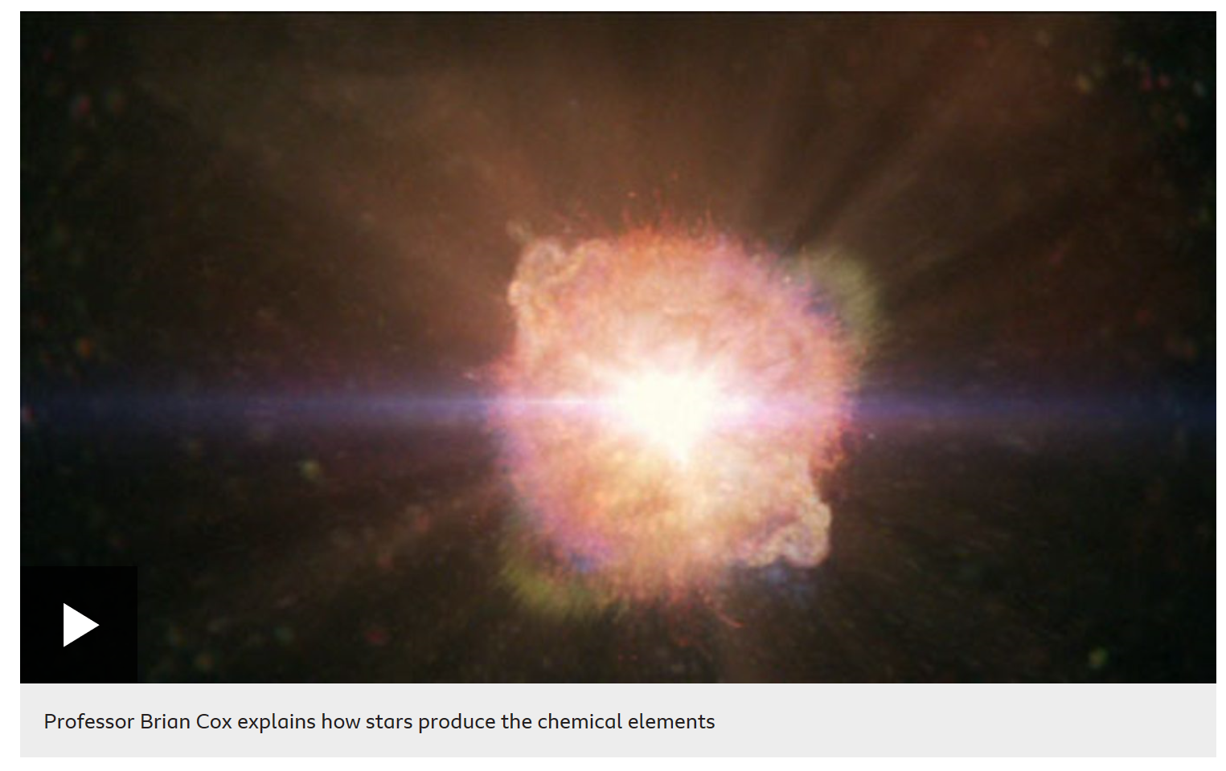

Complete the tasks on the next page:

Either print off and write the correct label in each box to show the life cycle of the star or type the correct the label into the boxes.
Neutron star
Black hole
Black dwarf
White dwarf
Supernova
Red super giant star
Red giant star
Main sequence star
prostar
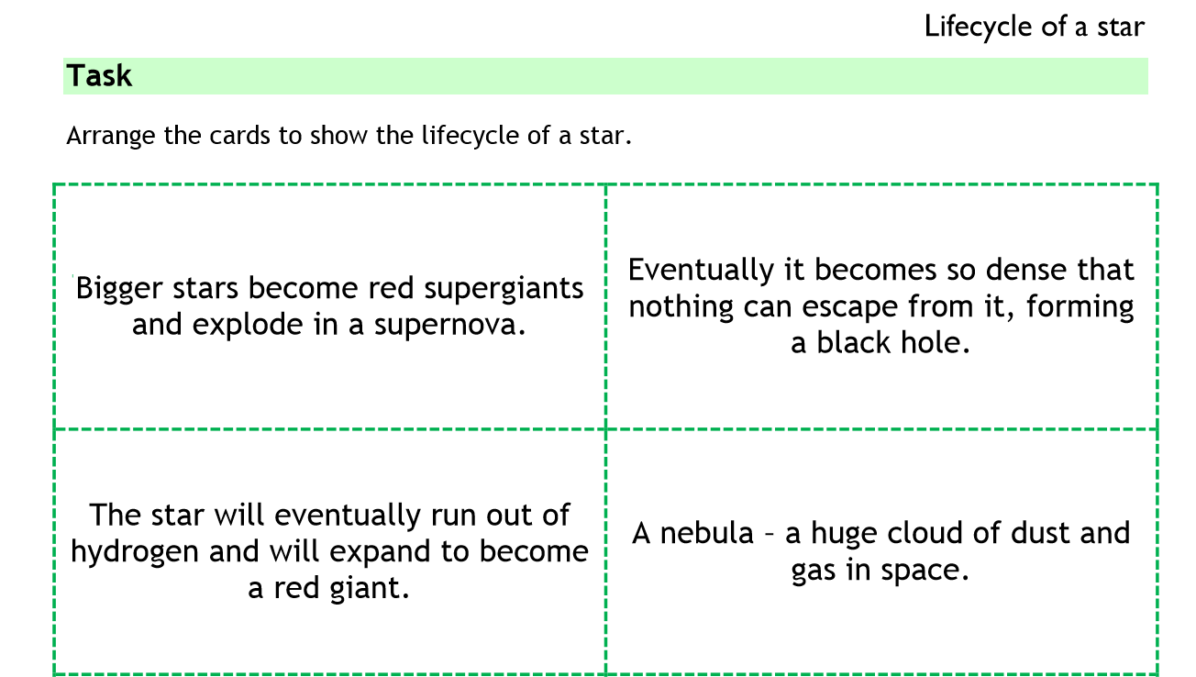
Either cut out the cards and arrange them in order or type or write the correct number in each box.

