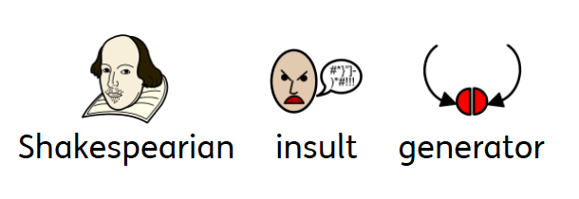
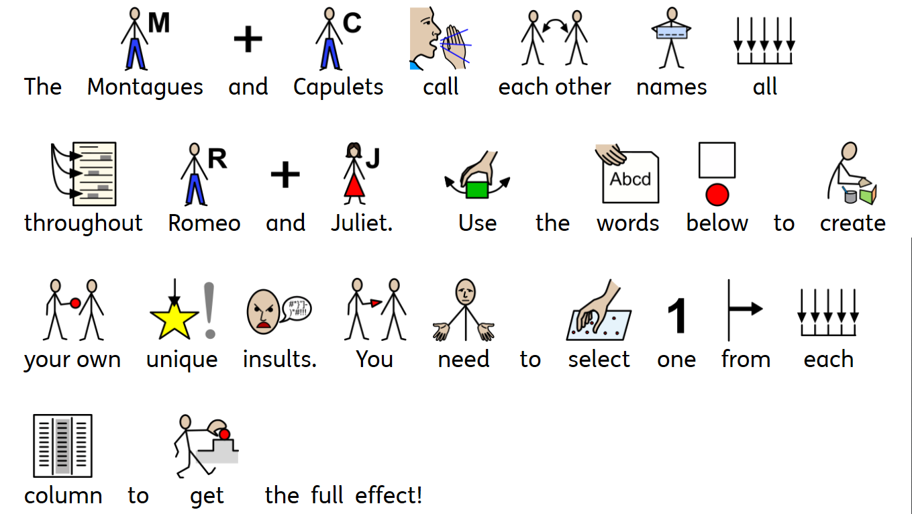

Bawdy  Beslubbering  Craven  Dankish  Errant  Frothy  Gorbellied  Loggerheaded  Mewling  Pribbling  Puking  Ruttish  Venomed  Weedy | beef-witted  beetle-headed  clapper-clawed  common-kissing  dizzy-eyed  fat-kidneyed  fly-bitten  full-gorged  hell-hated  knotty-pated  milk-livered  onion-eyed  pox-marked  swag-bellied | Baggage  Barnacle  Bum-bailey  Canker-blossom  Clotpole  Flax-wench  Haggard  Hedge-wig  Maggot-pie  Mouldwarp  Pig-nut  Strumpet  Whey-face  Wagtail

Write some of your insults in this box, for example “Bawdy, beef-witted Baggage”:

