Eurovision Literacy Assignment
Name: Date:

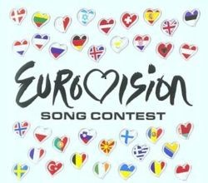

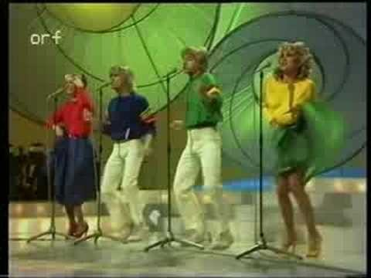
How It All Began
Did you know that not only stars like ABBA, Celine Dion, Cliff Richard and Julio Iglesias took part, but also dance act Riverdance thanks its fame to the Eurovision Song Contest?

The European Broadcasting Union (EBU) was formed on 12th February 1950 by 23 broadcasting organisations from Europe and the Mediterranean at a conference in Devon, United Kingdom.
The first EBU transmission was the Montreux Narcissus Festival on 6th of June, 1954. The viewers eagerly watched on four million television sets in homes, bars, and shop windows in Germany, Belgium, France, the United Kingdom, Italy, the Netherlands and Switzerland.

Ambitious Project

In 1955, the EBU came up with the idea of an international song contest. Countries would participate in one television show, to be transmitted simultaneously in all represented nations. The idea came about during a meeting in Monaco in 1955 by Marcel Bezençon, a Frenchman working for the EBU. The contest was seen as a technological experiment in live television. In those days, it was a very ambitious project to join many countries together in a wide international network. Satellite television did not exist at that time. The EBU was a terrestrial microwave network.
Le Grand-Prix Eurovision de la Chanson Européenne was born!

Eurovision Literacy Assignment
Name: Date:

The Successes

Without interruption, the Eurovision Song Contest has been broadcast every year since 1956, witch makes it one of the longest-running television programmes in the world. In 2003, the first ever Junior Eurovision Song Contest took place, while the Eurovision Song Contest celebrated its 50th anniversary 2005. Viewers picked ABBA's Waterloo as best ever Eurovision Song Contest song. In 2007, Europe saw the first ever Eurovision Dance Contest.
The 2008 running saw a record of 43 represented countries, as Azerbaijan and San Marino joined the family. The competition has been broadcast throughout Europe, but also in Australia, Canada, Egypt, Hong Kong, India, Jordan, Korea, New Zealand and the United States, even though these countries do not participate. In 2010 the format will be launched outside of Europe so that various other parts of the world will be introduced to the concept behind the show.

who can take part

eligible participants include all active members of the european broadcasting union active members are those whose states fall within the european broadcasting area or otherwise those who are members of the council of europe the european broadcasting area is defined by the international telecommunication union
eligibility to participate is not determined by geographic inclusion within the continent of europe despite the 'euro' in eurovision nor has it anything to do with the european union israel a middle eastern country has been taking part in the contest since 1973 in 1980 morocco a north african country participated in the contest
Source: www.eurovision.tv

Eurovision Literacy Assignment

Name:

Questions
Date:

- Name 3 famous acts that started off in The Eurovision.

- Where was the European Broadcasting Union formed?

- Highlight 3 nouns in the first paragraph.

- In your own words (1-2 sentences) describe why the Eurovision was an ambitious project.

- Find an adjective in the first paragraph.

- Name 2 spin-offs from the Eurovision Song Contest.

- Which countries joined the show in 2008?

- Which was the best ever Eurovision song?

- Can you watch The Eurovision in India?

- When was the first Eurovision Song Contest?

Tasks
- Punctuate the last section, “who can take part”. Add capital letters and full stops.
- Put the following countries in alphabetical order into the box below:
  - Montenegro

  - Slovenia
  - Belarus
  - Georgia
  - Slovakia
  - Poland
  - Portugal
  - Belgium
  - Germany
  - Monaco
- Look up the following words in a dictionary:
  - Broadcast
  - Respective
  - Terrestrial
  - Eligible
  - Contest
Put each of the words into a sentence:

a)

b)

c)

d)

e)

