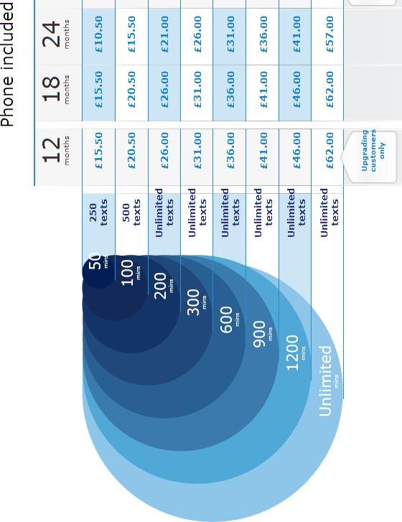
All charges shown are PER MONTH

Show all your working out clearly even if you use a calculator. Use extra paper if needed.
Look at the table and answer the following questions:

- How many different minute options are there?

- Which customers can have the 12 month based contract?

- What is the minimum and maximum number of minutes you can choose from?

- What is the minimum and maximum number of texts you can choose from?

- How much would the following cost:
  - 12 months / 50 mins

  - 18 months / 500 texts

  - 24 months / 1200 mins

- Which is cheaper – 12 months / 300mins OR 24 months / 900 mins

- I want to send lots of texts but I don’t have much money. Which is the best contract for me?

- What is the difference in cost between the most expensive and the cheapest contract?

- John is on 18 months / 900 mins and his sister is on 24 months / 500 texts. How much will they pay each month altogether?

- Which contract is the cheapest? Why might this be?

