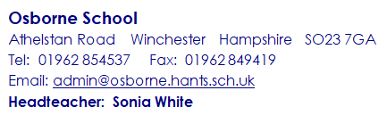
30 June 2022
Dear Parents and Carers
I hope that you are all well and looking forward to the Summer holidays.
I am writing to inform you of the events that are coming up at the end of the academic year which you are warmly invited, it would be lovely to see you and celebrate these with us.
2 July: Friends of Osborne school are putting on the Summer fete and there will be a whole range of activities for you to take part in. The fete starts at midday until 3.00pm.
12 July: There will be a whole school transition day for pupils to spend time with their new teachers in their new setting. All those leaving at the end of the Summer term will remain at home and our new year 7’s starting in September will be attending that day.
13 and 14 July: Osborne are putting on their first summer show since before the pandemic. We are doing two afternoon performances of MATILDA, so be sure to get your tickets when the letter is sent out to you.
20 July: This will be our first face-to face end of year presentation and Celebration Assembly since the pandemic. We have been lucky enough to secure the Bapsy Hall at the Winchester Guildhall, which if any of you have ever been there, is a really glorious venue. It would be great for you all to come along so that you can see snippets of what Osborne have been up to over the last year. The assembly will start at 10.30am and last about 2 hours and I am happy for your child to come straight to the Guildhall and then return home with you afterwards. Please return the reply slip when the letter is sent out to you.
21 July: This is the last day of term and school will finish at 12.30pm, please be aware that your child will be returning home on transport at this time. Your young person will also be coming home with their Annual Report and their attendance certificate.
I would also like to take this opportunity to thank you for your continued support of both the school and your young person this year. Whilst we have almost returned to normal since the pandemic I am hoping that the new academic year will allow us to have a full year where we will be doing all the normal activities that Osborne do.
Kind regards
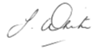
Sonia White
Headteacher

